Folio Plus™
Hotel Management System

User Guide

FOLIO PLUS
Professional Edition
Version 2.0.0
JANUARY 2007
Version Released:
NOVEMBER 2008
JINISYS Software, Inc.

Folio Plus Professional Edition
Version 2.0.0

Table of Contents:

Table of Contents: 2

LIABILITY DISCLAIMER 5

INTRODUCTION 6

I. THE FOLIO PLUS ENVIRONMENT 7

LOG-IN Screen 7
The MAIN Screen 7
Title Bar 8
Menu Bar 8
Tool Bar 8
System Audit Date/Time 8
Hotel Logo 9
Today’s Room Status 9
Today’s Room Status Summary 9
Occupancy Rate 9
Status Bar 10
Working Area 10

II. HOTEL CONFIGURATION 10

Hotel Information 10
INSERT New Hotel 10
EDIT Information of an existing Hotel 10
DELETE a Hotel 11
Departments 11
Insert New Department 11
Edit Information of a Department 11
DELETE a Department 11
Hotel Promos 12
Insert New Promo 12
Edit Information of a Promo 12
DELETE a Promo 12
Floor Pan 13
Insert New Floor 13
Edit Information of a Floor 13
DELETE a Floor Level 13
Currency 13
Insert New Currency 14
Edit Information of a Currency 14
DELETE a Currency 14
Rooms 14
Insert New Room 15
Edit Information of a Room 15
DELETE a Room 15
PLOT a Room’s coordinate 15
Room Types 15
Insert New Room Type 16
Edit Information of a Room 16

DELETE a Room Type 16
Room Amenities 16
Insert New Amenity 17
Edit Information of an Amenity 17
DELETE an Amenity 17
Rate Codes 17
Insert New Rate Code 18
Edit Information of a Rate Code 18
DELETE a Rate Code 18
Rate Types 18
Insert New Rate Type 18
Edit Information of a Rate Type 18
DELETE a Rate Type 19
Transaction Types 19
Insert New Transaction Type 19
Edit Information of a Transaction Type 19
DELETE a Transaction Type 19
Transaction Codes 19
Insert New Transaction Code 20
Edit Information of a Transaction Code 20
DELETE a Transaction Code 21
Transaction Code Sub-Accounts 21
Insert New Transaction Code Sub-Account 21
Edit Information of a Transaction Code Sub-Account 22
DELETE a Transaction Code Sub-Account 22
Transaction Source Documents 22
Insert New Transaction Source Document 23
Edit Information of a Transaction Source Document 23
DELETE a Transaction Source Document 23
Housekeeper 23
Insert New Housekeeper 23
Edit Information of a Housekeeper 23
a Housekeeper 24
Engineering Services 24
Insert New Engineering Service 24
Edit Information of an Engineering Service 24
DELETE an Engineering Service 24
Event Types 25
Insert New Event Type 25
Insert New Event Detail 25
Delete an Event Detail 25
Edit Information of an Event Type 25
Edit Information of an Event Detail 26
DELETE an Event Type 26
Event Package 26
Insert New Event Package 26
Add Package Requirement 26

Remove Package Requirement 26
Add Charges to Package 27
Remove Charges from a Package 27
Edit Information of Package 27
DELETE a Package 27
Event Requirements 27
Insert New Requirement 28
Add Requirement Detail 28
Remove Requirement Detail 28
Edit Information of a Requirement 28
DELETE a Requirement 28
Event Applied Rates 28

Insert New Applied Rate 29
Edit Information of an Applied Rate 29
DELETE an Applied Rate 29
Meal Items 29
Insert New Meal Item 30
Edit Information of a Meal Item 30
DELETE Meal Item 30
Meal Groups 30
Insert New Meal Group 31
Edit Information of a Meal Group 31
DELETE Meal Item 31
Meal Menu 31
Insert New Meal Menu 32
Edit Information of a Meal Menu 32
Add Meal Item to Meal Menu 32
Remove Meal Item to Meal Menu 32
DELETE Meal Menu 32
Individual Guests 32
Insert New Guest Account 33
Edit Information of a Guest Account 33
DELETE Guest Account 33
Add Privileges 33
Delete Privileges 33
Group Guests 34
Insert New Company Account 35
Edit Information of a Company Account 35
DELETE Company Account 35
Add Privileges 35
Delete Privileges 35
Taxi Drivers 35
Insert New Taxi Driver 36
Edit Information of a Company Account 36
DELETE Company Account 36
System Users 36
Insert New User Account 37
Edit Information of a User Account 37
DELETE User Account 37
Add Roles 37
Delete Privileges 37
Reset Password 37
User Roles 37
Insert New User Role 38
Edit Information of a User Role 38
DELETE User Role 38
System Configuration 38
Edit Information of a System Configuration 39

III. TRANSACTIONS (BASIC) 39
Guest List 39
Search for a Guest 39
Create New Reservation 39
Cancel Reservation 40
Single Reservation 40
Add Room Schedule to Reservation using Manual Input 41
Add Room Schedule to Reservation using Calendar Wizard 41
Add Room Schedule to Reservation using Auto-Rooming 41
Add/Remove Room Billing Instructions to Folio 41
Add/Remove Recurring Charges 42
Add/Remove Hotel Promos 42
Add/Remove Guest Privilege 43
Add/Remove Guests 44

Check-In through Reservation 44
Check-In using the Guest List 44
Check-In by viewing the Folio 44
Check-In using the Room Status 44
Check-In through Walk-In 44
Check-In using the Room Status 44
Folio Ledger List 45
Folio Ledger 45
Insert Transaction (Charges / Payments) 46
Recall Voided Transactions 46
Void Transactions 47
Check Out Folio 47
view the Check Out Window 47
Transfer Debit 47
Check Out Folio 48
Opening / Closing Shift 48
Open Cash Drawer 48
Close Cash Drawer 49
Day-End Closing 50
Process Night Audit 50

LIABILITY DISCLAIMER

JINISYS Software, Incorporated has prepared this document for use by its employees and client.
The information contained herein is the property of JINISYS Software, Incorporated and shall not be reproduced without prior written approval from JINISYS Software, Incorporated.
JINISYS Software, Incorporated reserves the right to change the specifications and functions, at any time without notice.

Conventions used:

- Denotes sub-menu
Denotes a tip is given.

⬧ Denotes a Frequently Asked Question

INTRODUCTION

What is Folio Plus Hotel Management System?

Folio Plus is software designed to make hotel service more efficient while making the lives of the hotel staff easier. The system provides the hotel with the capability to remember all its patrons through its Intellisense and has provisions for a tight security system. Thus, with Folio Plus, your patrons would feel valued and special.

I. THE FOLIO PLUS ENVIRONMENT

LOG-IN Screen

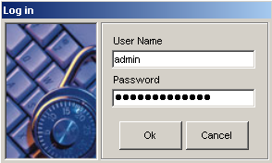

1

2

Figure 1

- User Name Text Box – System Users user name field. Each user is identified by user name.
- Password Text Box – Password field for each user.

The MAIN Screen
1
4
2
3

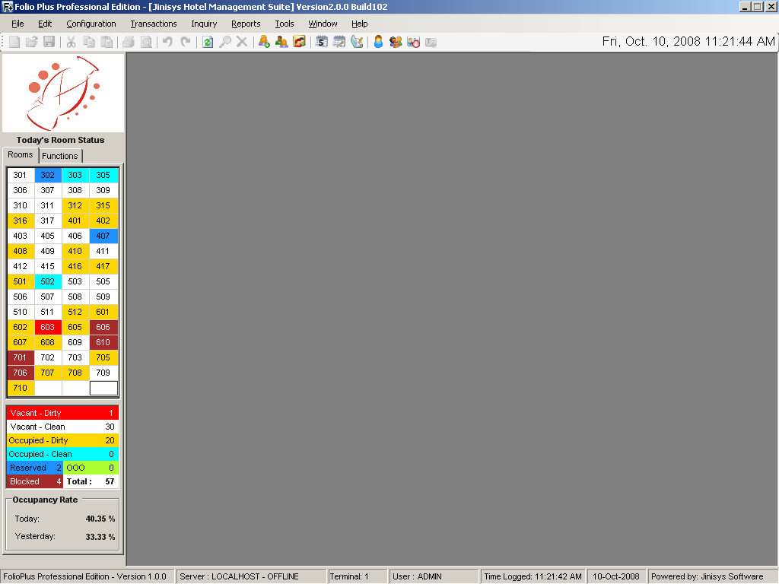

5
6
7

10

8

9

Figure 2

- Title Bar – the title of the application. Folio Plus Version, Build No. and Hotel Name will be displayed here.

Figure 3

- Menu Bar – holds all available system menus. (e.g. Hotel Information, Rooms)
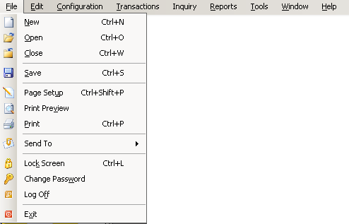

Figure 4

- Tool Bar – holds all short-cut buttons for faster navigation. Shows button name on mouse-over.

Figure 5

- System Audit Date/Time – displays audit date of the system irregardless of the actual date.

Figure 6

- Hotel Logo – displays the hotel logo. This logo will also be printed on hotel reports.



Figure 7

- Today’s Room Status – displays each room status (e.g. Occupied-Clean).

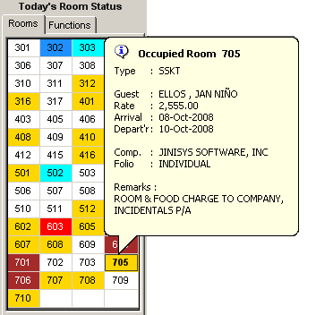

Figure 8


Did you know that…..?

You can view guest’s basic information by just pointing your mouse over a Room No.
You can use Today’s Room Status for Walk-In Check-In. Just double-click a Room No., and Reservation screen will show.

- Today’s Room Status Summary – display summary of Current Day Room Status (figure 8).
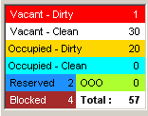

Figure 9

- Occupancy Rate – display Current and Previous Day Occupancy Rate

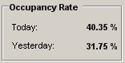

Figure 10

- Status Bar – displays the Database Server address, Terminal Name, Current logged user, Time logged and audit date of the system.

Figure 11
- Working Area – the Folio Plus working area. Displays equivalent screen on each command/menu accessed.
II. HOTEL CONFIGURATION

1. Hotel Information – holds the hotel name, no. of rooms, check-in time, check-out time, etc.
Location: ConfigurationHotelHotel Information
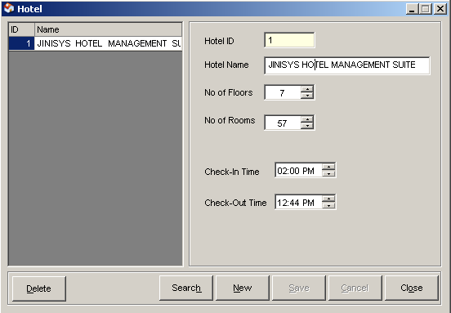
1
2
3
4
5
6
7
8
9
10
11
12
13

Figure 12

- List of Hotels – enumerates all manage hotels.
- Hotel Id Text box – holds the hotel id for each hotel. Hotel Id is the unique identifier for each hotel.
- Hotel Name – displays the hotel name.
- No. of Floors – displays the number of floors per hotel.
- No of Rooms – displays the number of rooms per hotel.
- Check-In Time – default check-in time per hotel.
- Check-Out Time – default check-out time per hotel.
- Delete button – removes selected hotel.
- Search button – search for a specific hotel.
- New button – prepares the screen for a new hotel entry.
- Save button – saves hotel information changes or new hotel.
- Cancel button – discards any hotel information changes.
- Close button – close Hotel Information screen.

⬧ How to INSERT New Hotel

  - Click NEW button, and encode Hotel ID, and Hotel Information. Hotel ID should be supplied and must be unique per hotel entry.
  - Once done, click the SAVE button

⬧ How to EDIT Information of an existing Hotel

- Select Hotel from List of Hotels, and edit its information. Hotel ID should not be changed since this is the unique identifier of the hotel.
- Once done, click the SAVE button.

⬧ How to DELETE a Hotel

- Select Hotel from List of Hotels, and click the DELETE button.
- A confirmation box will appear, and click YES if you want to DELETE selected hotel.

Did you know that…..?

Yellow-colored text boxes are required fields. Required fields are mandatory when you insert/edit a record.

2. Departments – records all departments in a hotel.
Location: ConfigurationHotelDepartments
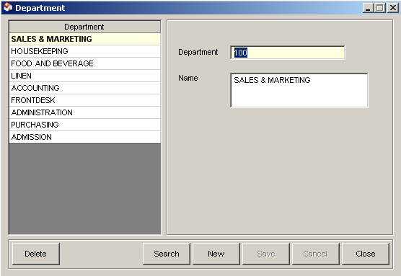
1
2
3
4
5
6
7
8
9

Figure 13

- List of Departments – enumerates all departments.
- Department text box – displays the department code of the selected department.
- Name text box – displays the department name of the selected department.
- Delete button – removes selected department.
- Search button – search for a specific department.
- New button – prepares the screen for a new department entry.
- Save button – saves department changes or new department.
- Cancel button – discards any department changes.
- Close button – close Department screen.

⬧ How to Insert New Department

- Click NEW button, and encode Department ID, and Department Name. Department ID should be supplied and must be unique per department.
- Once done, click the SAVE button

⬧ How to Edit Information of a Department

- Select Department from List of Departments, and edit its information. Department ID should not be changed since this is the unique identifier of the department.
- Once done, click the SAVE button.

⬧ How to DELETE a Department

- Select Department from List of Departments, and click the DELETE button.
- A confirmation box will appear, and click YES if you want to DELETE selected department.

3. Hotel Promos – records all hotel promos.
Location: ConfigurationHotelPromos
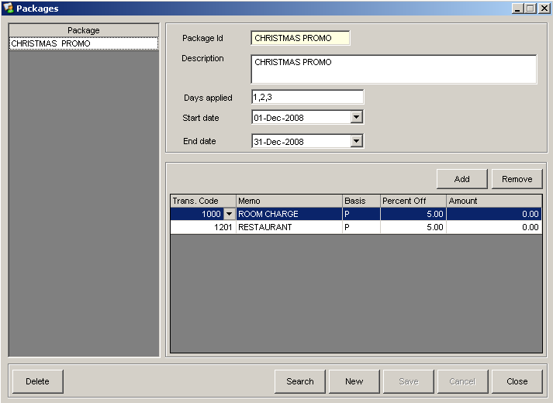
1
2
3
4
5
6
10
11
12
13
14
15
7
8
9

Figure 14

- List of Hotel Promos – enumerates all hotel promos.
- Package ID text box – display the promo id.
- Description text box – displays the promo description.
- Days Applied – displays how the promo should be applied per guest. Should it be applied daily or on an interval?
- Start Date – displays the date when the promo will be active.
- End Date – displays the date when the promo will be inactive.
- Add button – adds a new Transaction to promo discount list.
- Remove button – removes an entry in the promo discount list.
- Promo discounts list – enumerates all promo discounts.
- Delete button – removes selected promo.
- Search button – search for a specific promo.
- New button – prepares the screen for a new promo entry.
- Save button – saves promo changes or new hotel promo.
- Cancel button – discards any promo changes.
- Close button – close Hotel Promo screen.

⬧ How to Insert New Promo

  - Click NEW button, and encode Promo ID, and details of the promo. Promo ID should be supplied and must be unique per promo.
  - To add a new transaction, click the ADD button, and choose basis of discount (Percent or Amount), input discount percent or amount on the next cell. Percent discount should not exceed 100%.
  - Once done, click the SAVE button

⬧ How to Edit Information of a Promo

- Select Promo from List of Promos, and edit its information.
- To remove an existing transaction, click the REMOVE button.
- To edit, just click on the percent or amount column, and edit.
- Once done, click the SAVE button.

⬧ How to DELETE a Promo

  - Select Promo from List of Promos, and click the DELETE button.
  - A confirmation box will appear, and click YES if you want to DELETE selected promo.
Did you know that…..?

Days Applied makes Hotel Promos flexible. You can have a promo such as “3 + 1”. For every 3 nights of stay at the hotel, you can have the 4th night free.

4. Floor Pan – records all hotel floors.
Location: ConfigurationHotelFloor Plan

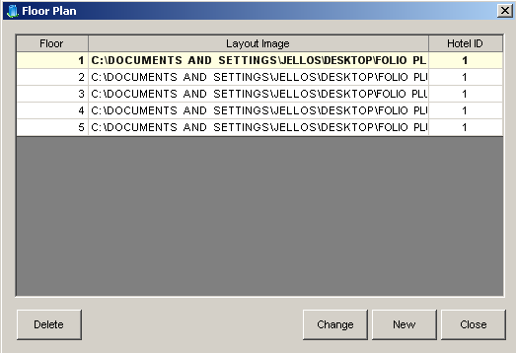
1
2
3
4
5

Figure 15

- Floor list – enumerates hotel floors.
- Delete button – deletes selected floor number.
- Change button – replace existing floor layout image.
- New button - prepares the screen for a new promo entry.
- Close button – close Floor Plan screen.

⬧ How to Insert New Floor

- Click NEW button, and encode Floor Level, and locate file of floor layout.
- Once done, click the SAVE button

⬧ How to Edit Information of a Floor

- Select Floor from List of Floor Levels, and edit its information. Floor Level should not be changed since this is its unique identifier.
- Once done, click the SAVE button.

⬧ How to DELETE a Floor Level

- Select Floor from List of Floor Levels, and click the DELETE button.
- A confirmation box will appear, and click YES if you want to DELETE selected floor level.

5. Currency – records all acceptable currency for the hotel.
Location: ConfigurationCurrency Codes
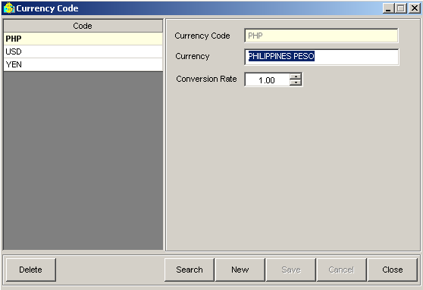
1
2
3
4
5
6
7
8
9
10

Figure 16

- Currency List – enumerates all currency codes.
- Currency Code text box – displays currency code of selected currency.
- Currency text box – displays currency description of the selected currency.
- Conversion rate field – displays the exchange rate per currency.
- Delete button – removes selected currency.
- Search button – search for a specific currency.
- New button – prepares the screen for a new currency entry.
- Save button – saves currency changes or new currency.
- Cancel button – discards any currency changes.
- Close button – close Currency Code screen.

⬧ How to Insert New Currency

  - Click NEW button, and encode Currency Code, description and conversion rate. Base currency is PHP.
  - Once done, click the SAVE button

⬧ How to Edit Information of a Currency

- Select Currency from List of Currency, and edit its information. Currency Code should not be changed since this is its unique identifier.
- Once done, click the SAVE button.

⬧ How to DELETE a Currency

- Select Currency from List of Currency, and click the DELETE button.
- A confirmation box will appear, and click YES if you want to DELETE selected currency.

6. Rooms – records all rooms in a hotel.
Location: ConfigurationRoomRooms

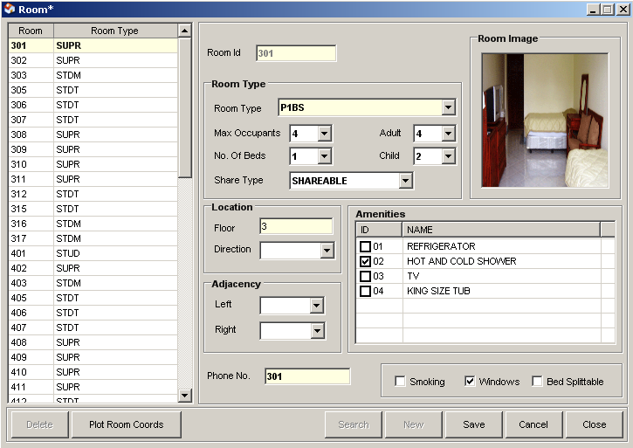
1
2
3
4
5
6
8
9
7
10
11
12
13
14
15
16
17
18

Figure 17

- List of Rooms – enumerates all rooms.
- Room Id text box – displays room no. Room No. is unique per room.
- Room Type – displays the room type of the Room.
- Room Image – displays room image. To change room’s image, just click on this box.
- Location box – displays room location. Floor level and direction facing.
- Adjacency box – displays the adjacent rooms to current room selected.
- Phone No. text box – displays the local number of the room.
- Amenities list – enumerates all available amenities and puts check mark if amenities are available in the room.
- Smoking check-box – displays if smoking is allowed in the room.
- Windows check-box – displays if room has windows.
- Bed splittable check-box – displays if room’s bed could be split.
- Delete button – remove currently selected room.
- Plot room coordinates – shows a floor layout image where to plot the room coordinates(x, y).
- Search button – search for a specific room.
- New button – prepares the screen for a new room entry.
- Save button – save changes to selected room or new room.
- Cancel button – discards any changes made to currently selected room.
- Close button – close Room screen.

⬧ How to Insert New Room

  - Click NEW button, and encode Room No, select Room Type from the list of room types. Input floor level and other room information. Room No should be unique per room.
  - Once done, click the SAVE button

⬧ How to Edit Information of a Room

- Select Room from List of Rooms, and edit its information. Room Number should not be changed since this is its unique identifier.
- Once done, click the SAVE button.

⬧ How to DELETE a Room

- Select Room from List of Room, and click the DELETE button.
- A confirmation box will appear, and click YES if you want to DELETE selected room.

⬧ How to PLOT a Room’s coordinate

- Click “Plot Room Coords” button, and floor layout image will appear.
- Click on the location of the room, and click UPDATE button. System will take you back to Room Configuration.
- Click SAVE button to update room coordinates.

Did you know that…..?

You can have a larger view of room’s image. Just point your mouse over the room image box and a bigger image will appear.
Telephone No. will be the basis for auto-charging of Guests Folio.

7. Room Types – records all room types of the hotel.
Location: ConfigurationRoomRoom Types
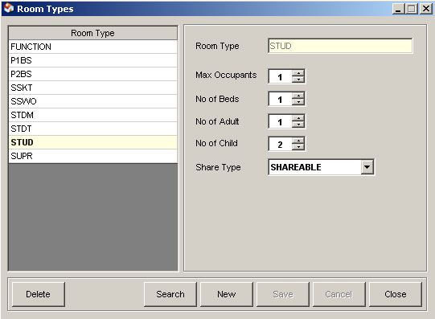
1
2
8
9
10
3
4
5
6
7
11
12
13

Figure 18

- List of Room Types – enumerates all hotel room types.
- Room Type text box – displays name of currently selected room type.
- Max Occupants field – displays the maximum number of occupants a room type can accommodate.
- No. of Beds – displays the total number of beds.
- No. of Adult – displays the total number of adult a room type can accommodate.
- No. of Child – displays the total number of child a room type can accommodate.
- Shareable field – displays if a room type is shareable or not.
- Delete button – removes selected room type.
- Search button – search for a specific room type.
- New button – prepares the screen for a new room type entry.
- Save button – saves room type changes or new room type.
- Cancel button – discards any room type changes.
- Close button – close Room Type screen.

⬧ How to Insert New Room Type

  - Click NEW button, and encode Room Type. Room Type should be unique.
  - Once done, click the SAVE button

⬧ How to Edit Information of a Room

- Select Room Type from List of Room Types, and edit its information. Room Type should not be changed since this is its unique identifier.
- Once done, click the SAVE button.

⬧ How to DELETE a Room Type

- Select Room Type from List of Room Types, and then click the DELETE button.
- A confirmation box will appear, and click YES if you want to DELETE selected room type.

8. Room Amenities – records all room amenities.
Location: ConfigurationRoomRoom Amenities
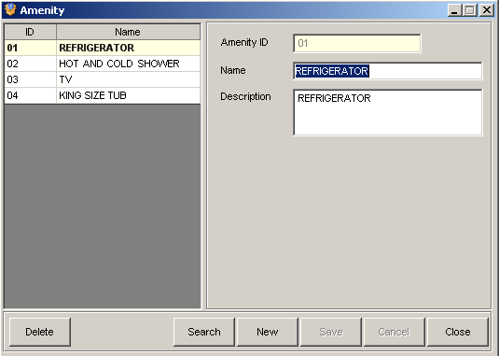
1
5
6
7
8
9
10
2
3
4

Figure 19

- List of Amenities – enumerates all amenities.
- Amenity ID text box – display the amenity id of the selected amenity.
- Name text box – displays the amenity name.
- Description – displays the description of the amenity.
- Delete button – removes selected amenity.
- Search button – search for a specific amenity.
- New button – prepares the screen for a new amenity entry.
- Save button – saves amenity changes or new amenity.
- Cancel button – discards any amenity changes.
- Close button – close Amenity screen.

⬧ How to Insert New Amenity

  - Click NEW button, and encode Amenity information. Amenity ID should be unique.
  - Once done, click the SAVE button.

⬧ How to Edit Information of an Amenity

- Select Amenity from List of Amenities, and edit its information. Amenity ID should not be changed since this is its unique identifier.
- Once done, click the SAVE button.

⬧ How to DELETE an Amenity

- Select Amenity from List of Amenities, and click the DELETE button.
- A confirmation box will appear, and click YES if you want to DELETE selected amenity.

9. Rate Codes – records all rates codes.
Location: ConfigurationRoom RatesRate Codes
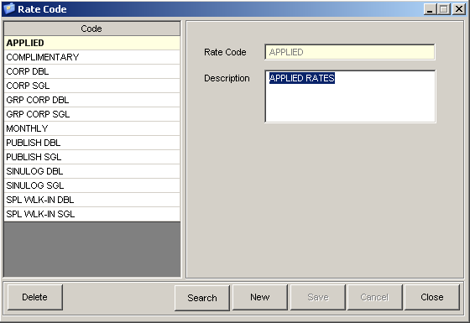
1
2
3
4
5
6
7
8
9

Figure 20

- List of Rate Codes – enumerates all rate codes.
- Rate Code text box – displays rate code.
- Description text box – displays description of the selected rate code.
- Delete button – removes selected rate code.
- Search button – search for a specific rate code.
- New button – prepares the screen for a new rate code entry.
- Save button – saves rate code changes or new rate code.
- Cancel button – discards any rate code changes.
- Close button – close Rate Code screen.

⬧ How to Insert New Rate Code

- Click NEW button, and encode Rate Code, and description. Rate Code should be unique.
- Once done, click the SAVE button.

⬧ How to Edit Information of a Rate Code

- Select Rate Code from List of Rate Codes, and edit its information. Rate Code should not be changed since this is its unique identifier.
- Once done, click the SAVE button.
⬧ How to DELETE a Rate Code

- Select Rate Code from List of Rate Codes, and click the DELETE button.
- A confirmation box will appear, and click YES if you want to DELETE selected Rate Code.

10. Rate Types – records all rate types.
Location: ConfigurationRoom RatesRate Codes

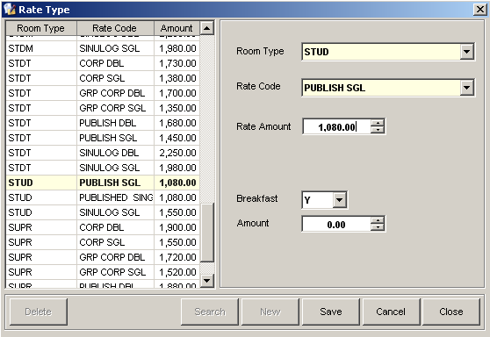
1
2
3
7
8
9
10
11
12
4
5
6

Figure 21

- List of Rate Types – list of configured rate types.
- Room Type field – displays the Room Type of the selected rate type.
- Rate Code field – displays the Rate Code of the selected rate type.
- Rate Amount field – displays the Rate Amount of the selected rate type.
- Breakfast field – displays if selected rate type has Breakfast.
- Breakfast Amount field – displays the amount if has breakfast.
- Delete button – removes selected rate type.
- Search button – search for a specific rate type.
- New button – prepares the screen for a new rate type entry.
- Save button – saves rate type changes or new rate type.
- Cancel button – discards any rate type changes.
- Close button – close Rate Type screen.

⬧ How to Insert New Rate Type

  - Click NEW button, and select Room Type, and Rate Code. Encode Rate Amount, and breakfast component of the Rate Type.
  - Once done, click the SAVE button.

⬧ How to Edit Information of a Rate Type

- Select Rate Type from List of Rate Types, and edit its information.
- Once done, click the SAVE button.

⬧ How to DELETE a Rate Type

- Select Rate Type from List of Rate Types, and click the DELETE button.
- A confirmation box will appear, and click YES if you want to DELETE selected Rate Type.

11. Transaction Types – records all transaction types. Transaction Types are groups of transaction codes.
Location: ConfigurationTransactionTransaction Types

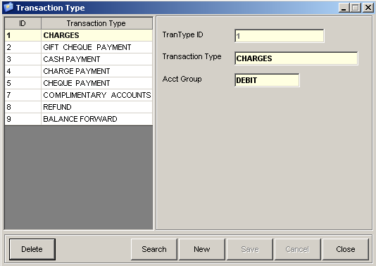
1
2
3
5
6
7
10
4
8
9

Figure 22

- List of Transaction Types – enumerates all transaction types.
- TranType ID – displays the transaction type ID.
- Transaction Type – displays the description of the Transaction Type.
- Acct Group – displays the account side of Transaction Type.
- Delete button – removes selected transaction type.
- Search button – search for a specific transaction type.
- New button – prepares the screen for a new transaction type entry.
- Save button – saves transaction type changes or new transaction type.
- Cancel button – discards any transaction type changes.
- Close button – close Transaction Type screen.

⬧ How to Insert New Transaction Type

  - Click NEW button, and input Transaction Type ID, and description. Transaction Type ID should be unique per Transaction Type.
  - Once done, click the SAVE button.

⬧ How to Edit Information of a Transaction Type

- Select Transaction Type from List of Transaction Types, and edit its information.
- Once done, click the SAVE button.

⬧ How to DELETE a Transaction Type

- Select Transaction Type from List of Rate Types, and click the DELETE button.
- A confirmation box will appear, and click YES if you want to DELETE selected Transaction Type.

12. Transaction Codes – records all transaction codes.
Location: ConfigurationTransactionTransaction Codes
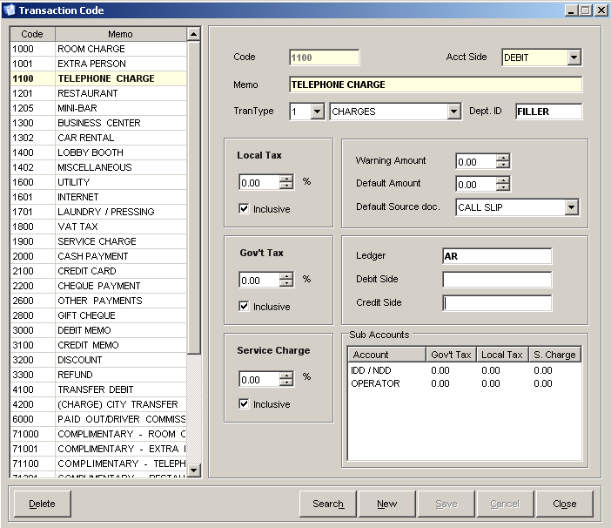
1
2
3
5
4
6
7
8
12
13
17
18
9
10
11
14
15
16
19
20
21
22
25
23
24

Figure 23

- List of Transaction Codes – enumerates all existing Transaction Codes.
- Code text box – displays transaction code.
- Memo text box – displays description of transaction code.
- Transaction type drop-down box – displays the transaction type of selected Transaction Code.
- Accounting Side drop-down box – displays Account Side (Debit/Credit) or selected Transaction Code.
- Department ID text box – displays Department Id of transaction code. Department is used for Service Charge splitting.
- Local Tax text box – displays local tax setting of selected Transaction Code.
- Local Tax Inclusive check-box – displays if local tax is inclusive or not.
- Warning Amount text box – displays warning amount of Transaction Code.
- Default Amount text box – displays default amount of Transaction Code.
- Default Source Document drop-down box – displays the default Source Document of transaction.
- Government Tax or VAT text box - displays government tax setting of selected Transaction Code.
- Government Tax Inclusive check-box – displays if government tax is inclusive or not.
- Ledger text box – displays LEDGER destination of transaction if posted to an Accounting Ledger.
- Debit Side text box – displays debit side Account Code mapped to Accounting System.
- Credit Side text box – displays credit side Account Code mapped to Accounting System.
- Service Charge text box – displays service charge setting of selected Transaction Code.
- Service Charge check-box – displays if service charge of selected Transaction is inclusive or not.
- Sub-Account List – enumerates Transaction Code’s sub-accounts.
- Delete button – removes selected transaction code.
- Search button – search for a specific transaction code.
- New button – prepares the screen for a new transaction code entry.
- Save button – saves transaction code changes or new transaction code.
- Cancel button – discards any transaction code changes.
- Close button – close Transaction Code screen.

⬧ How to Insert New Transaction Code

  - Click NEW button, and input Transaction Code and Memo. Encode Transaction Code information. Transaction Code is unique per Transaction.
  - Once done, click the SAVE button.

⬧ How to Edit Information of a Transaction Code

- Select Transaction Code from List of Transaction Codes, and edit its information.
- Once done, click the SAVE button.

⬧ How to DELETE a Transaction Code

- Select Transaction Code from List of Transaction Codes, and click the DELETE button.
- A confirmation box will appear, and click YES if you want to DELETE selected Transaction Code.

13. Transaction Code Sub-Accounts – records all transaction codes sub-accounts.
Location: ConfigurationTransactionTransaction Code Sub-Accounts
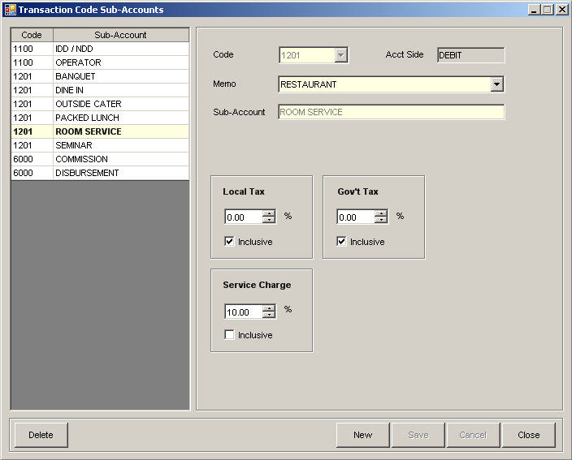
1
2
3
4
5
6
7
10
11
9
8
12
13
16
14
15

Figure 24

- List of Sub-Accounts – enumerates all active Transaction Code Sub-Accounts.
- Code drop-down box – displays a list of Transaction Codes.
- Memo text box – displays selected Transaction Code description.
- Account Side text box – displays Account Side (DEBIT/CREDIT) of selected Transaction Code.
- Sub-Account text box – displays Sub-Account description of selected Transaction Code Sub-Account.
- Local Tax text box – displays local tax setting of selected Transaction Code Sub-Account.
- Local Tax Inclusive check-box – displays if local tax is inclusive or not.
- Government Tax or VAT text box - displays government tax setting of selected Transaction Code Sub-Account.
- Government Tax Inclusive check-box – displays if government tax is inclusive or not.
- Service Charge text box – displays service charge setting of selected Transaction Code Sub-Account.
- Service Charge check-box – displays if service charge of selected Transaction is inclusive or not.
- Delete button – removes selected transaction code sub-account.
- Search button – search for a specific transaction code sub-account.
- New button – prepares the screen for a new transaction code sub-account entry.
- Save button – saves transaction code sub-account changes or new transaction code sub-account.
- Cancel button – discards any transaction code sub-account changes.
- Close button – close Transaction Code Sub-Account screen.

⬧ How to Insert New Transaction Code Sub-Account

  - Click NEW button, and select Transaction Code. Encode Transaction Code Sub-Account description. Transaction Code Sub-Account is unique per Transaction Code.
  - Once done, click the SAVE button.

⬧ How to Edit Information of a Transaction Code Sub-Account

- Select Transaction Code from List of Transaction Code Sub-Accounts, and edit its information. Sub-Account is unique per Transaction and can’t be altered.
- Once done, click the SAVE button.

⬧ How to DELETE a Transaction Code Sub-Account

- Select Transaction Code Sub-Account from List of Sub-Accounts, and click the DELETE button.
- A confirmation box will appear, and click YES if you want to DELETE selected Sub-Account.

14. Transaction Source Documents – records all transaction source documents.
Location: ConfigurationTransactionTransaction Sources

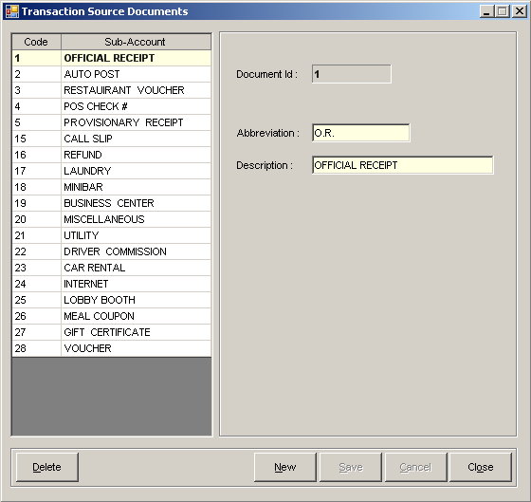
1
2
3
4
5
6
7
8
9

Figure 25

- List of Transaction Source Documents – enumerates all active Transaction Source Documents.
- Document Id text box – displays Transaction Source Document Id.
- Abbreviation text box – displays document’s abbreviation.
- Description text box – displays document’s description.
- Delete button – removes selected transaction source document.
- New button – prepares the screen for a new transaction source document entry.
- Save button – saves transaction source document changes or new transaction source document.
- Cancel button – discards any transaction source document changes.
- Close button – close Transaction Source Document screen.

⬧ How to Insert New Transaction Source Document

  - Click NEW button, Document Id is automatically set by the system. Encode document abbreviation and description. Document Id is unique per Transaction Source.
  - Once done, click the SAVE button.

⬧ How to Edit Information of a Transaction Source Document

- Select Transaction Source Document from List of Transaction Source Documents, and edit its information. Document Id is unique per Transaction Source Document and can’t be altered.
- Once done, click the SAVE button.

⬧ How to DELETE a Transaction Source Document

- Select Transaction Source Document from List of Transaction Source Documents, and click the DELETE button.
- A confirmation box will appear, and click YES if you want to DELETE selected Source Document.

15. Housekeeper – records all hotel housekeepers.
Location: ConfigurationServices Housekeepers
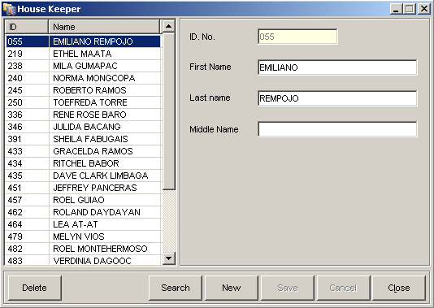
1
2
3
4
5
6
7
8
9
10
11

Figure 26

- List of Housekeepers – enumerates all hotel housekeepers.
- ID No. text box – displays ID No. of Housekeeper.
- First Name text box – displays Housekeeper’s First Name.
- Last Name text box – displays Housekeeper’s Last Name.
- Middle Name text box – displays Housekeeper’s Middle Name.
- Delete button – removes selected Housekeeper.
- Search button – search for a specific housekeeper.
- New button – prepares the screen for a new housekeeper entry.
- Save button – saves housekeeper changes or new housekeeper.
- Cancel button – discards any housekeeper information change.
- Close button – close Housekeeper screen.

⬧ How to Insert New Housekeeper

  - Click NEW button. Input Housekeeper ID and name. Housekeeper is unique per housekeeper.
  - Once done, click the SAVE button.

⬧ How to Edit Information of a Housekeeper

- Select Housekeeper from List of Housekeepers, and edit its information. Housekeeper Id is unique per Housekeeper and can’t be altered.
- Once done, click the SAVE button.

⬧ How to DELETE a Housekeeper

- Select Housekeeper from List of Housekeepers, and click the DELETE button.
- A confirmation box will appear, and click YES if you want to DELETE selected Housekeeper.

17. Engineering Services – records all engineering services.
Location: ConfigurationServices Engineering Services
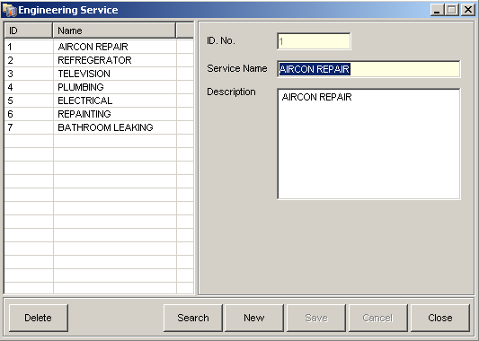
1
2
3
4
5
6
7
8
9
10

Figure 27

- List of Engineering Services – enumerates all Engineering Services.
- ID No. text box – displays engineering service Id.
- Service Name text box – displays Engineering Service name.
- Description text box – displays Engineering Service description.
- Delete button – removes selected Engineering Service.
- Search button – search for a specific Engineering Service.
- New button – prepares the screen for a new engineering service entry.
- Save button – saves engineering service changes or new engineering service.
- Cancel button – discards any engineering service information change.
- Close button – close Engineering Service screen.

⬧ How to Insert New Engineering Service

  - Click NEW button. Input Engineering Service ID, and description. Engineering Service is unique per Engineering Service.
  - Once done, click the SAVE button.

⬧ How to Edit Information of an Engineering Service

- Select Engineering Service from List of Engineering Services, and edit its information. Engineering Service Id is unique per Engineering Service and can’t be altered.
- Once done, click the SAVE button.

⬧ How to DELETE an Engineering Service

- Select Engineering Service from List of Engineering Services, and click the DELETE button.
- A confirmation box will appear, and click YES if you want to DELETE selected Engineering Service.

18. Event Types – records all event types. Event Types are used in setting-up of Event Packages.
Location: ConfigurationEvents Event Types
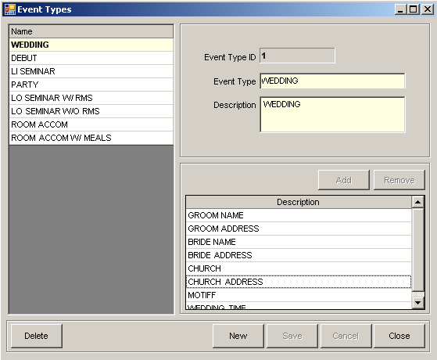
1
2
3
4
5
6
7
8
9
10
11
12

Figure 28

- List of Event Types – enumerates all active event types.
- Event Type Id text box – displays event type id.
- Event Type text box – displays event type name.
- Description text box – displays description of event type.
- Add button – add new entry to list of event details.
- Remove button – remove selected event detail.
- List of Event Details – enumerates all event details.
- Delete button – removes selected Event Type.
- New button – prepares the screen for a new Event Type entry.
- Save button – saves event type changes or new event type.
- Cancel button – discards any event type information change.
- Close button – close Event Type screen.

⬧ How to Insert New Event Type

  - Click NEW button. Event Id is automatically assigned by system. Input Event Name and description. Event Id is unique per Event Type.
  - Once done, click the SAVE button.

⬧ How to Insert New Event Detail

1. Click Add button, and encode event detail on the empty cell provided.

⬧ How to Delete an Event Detail

1. Select event detail from List of Event Details and click Remove button.

⬧ How to Edit Information of an Event Type

1. Select Event Type from List of Event Types, and edit its information. Event Id is unique per Event Type and can’t be altered.

2. Once done, click the SAVE button.

⬧ How to Edit Information of an Event Detail

- Select Event Detail from List of Event Details and edit details.
- Once done, click the Save button.

⬧ How to DELETE an Event Type

- Select Event Type from List of Event Types, and click the DELETE button.
- A confirmation box will appear, and click YES if you want to DELETE selected Event Type.

19. Event Package – records all event packages.
Location: ConfigurationEvents Package

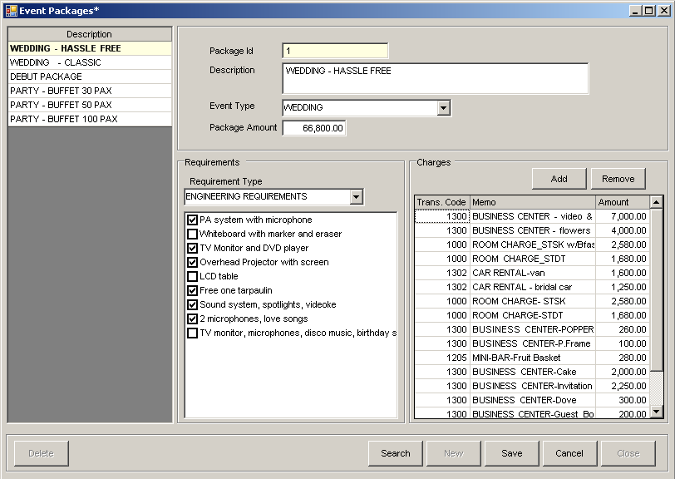
1
2
3
4
5
6
7
8
9
10
11
12
13
14
14
15

Figure 29

- List of Packages – enumerates all active Event Package.
- Package ID text box – displays package Id of selected event package.
- Description text box – displays description of selected event package.
- Event Type text box – displays event type of selected event package.
- Package Amount text box – displays package amount of selected event package.
- Event Requirement drop-down box – displays all event requirements.
- Event Requirement details list – displays a list of all event requirements per requirement type.
- Add button – adds a new entry to list of package inclusions.
- Remove button – removes selected entry in package inclusions.
- List of Package Inclusions – enumerates all packages inclusions with amount.
- Delete button – removes selected Event Package.
- Search button – search for a specific Event Package.
- New button – prepares the screen for a new Event Package entry.
- Save button – save changes to a new or existing Event Package.
- Close button – close Event Package screen.

⬧ How to Insert New Event Package

1. Click NEW button. Package Id is automatically assigned by the system. Input event description, type and amount. Package Id is unique per Package.

2. Once done, click the SAVE button.
⬧ How to Add Package Requirement

- Select requirement type from the Requirement Type drop-down box.
- Place a “check” mark on the requirements needed per package.
- Once done, click Save button.

⬧ How to Remove Package Requirement

- Select requirement type from the Requirement Type drop-down box.
- Uncheck on the requirement you want to remove.
- Once done, click the Save button.

⬧ How to Add Charges to Package

- Click the Add button. An empty cell next to the last inserted charge will appear. Choose Transaction code from the List.
- Change Transaction description if necessary. Input amount of charge.
- Once done, click the Save button.

⬧ How to Remove Charges from a Package

- Select Charge to remove from the List of Package Charges.
- Click Remove button.
- Once done, click the Save button.

⬧ How to Edit Information of Package

- Select Package from List of Event Packages, and edit its information. Package Id is unique per Package and can’t be altered.
- Once done, click the SAVE button.

⬧ How to DELETE a Package

- Select Package from the List of Packages, and click the DELETE button.
- A confirmation box will appear, and click YES if you want to DELETE selected Package.

20. Event Requirements – records all event requirements. Event Requirements are used in setting up Event Package.
Location: ConfigurationEvents Requirements

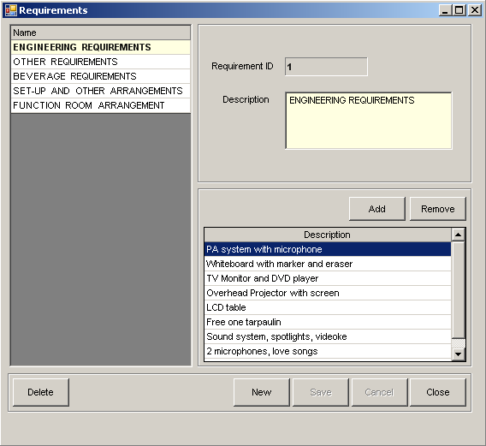
2
1
3
4
5
6
7
8
9
10
11

Figure 30

- List of Requirements – enumerates all active event requirements.
- Requirement Id text box – displays requirement Id. Requirement Id is unique per Requirement.
- Description text box – displays requirement description.
- Add button – adds new entry to requirement details list.
- Remove button – removes an entry from the requirement details list.
- List of Requirement Details – enumerates requirement details.
- Delete button – removes selected Requirement.
- New button – prepares the screen for a new Requirement entry.
- Save button – save changes to a new or existing Requirement.
- Cancel button – discards any changes to Requirement.
- Close button – close Requirement screen.

⬧ How to Insert New Requirement

  - Click NEW button. Requirement Id is automatically assigned by the system. Input requirement description. Requirement Id is unique per Requirement.
  - Once done, click the SAVE button.

⬧ How to Add Requirement Detail

- Click the Add button. An empty cell next to the last inserted charge will appear. Input requirement detail description on the empty cell.
- Once done, click the Save button.

⬧ How to Remove Requirement Detail

- Select Requirement Detail to remove from the List of Requirement Details.
- Click Remove button.
- Once done, click the Save button.

⬧ How to Edit Information of a Requirement

- Select Requirement from List of Event Requirements, and edit its information. Requirement Id is unique per Requirement and can’t be altered.
- Once done, click the SAVE button.

⬧ How to DELETE a Requirement

- Select Requirement from the List of Requirements, and click the DELETE button.
- A confirmation box will appear, and click YES if you want to DELETE selected Requirement.

21. Event Applied Rates – records all event’s Applied Rates. Applied Rates are used upon Group Check-In with Room Accommodation.
Location: ConfigurationEventsApplied Rates

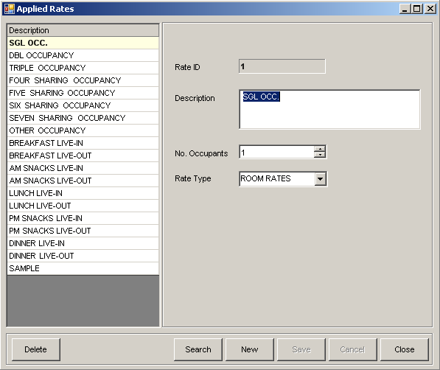
1
2
3
4
5
6
7
8
9
10
11

Figure 31

- List of Applied Rates – enumerates all active Applied Rates.
- Rate Id text box – displays the Applied Rate Id of the selected Applied Rate.
- Description text box – displays the description of the selected Applied Rate.
- No. Of Occupants – displays the No. of Occupants of the selected Applied Rate.
- Rate Type drop-down box – displays the Rate Type of the selected Applied Rate.
- Delete button – removes selected Applied Rate.
- Search button – search for a specific Applied Rate.
- New button – prepares the screen for a new Applied Rate entry.
- Save button – save changes to a new or existing Applied Rate.
- Cancel button – discards any changes to Applied Rate.
- Close button – close Applied Rate screen.

⬧ How to Insert New Applied Rate

  - Click NEW button. Rate Id is automatically assigned by the system. Input requirement description, no. of occupants and rate type. Rate Id is unique per Applied Rate.
  - Once done, click the SAVE button.

⬧ How to Edit Information of an Applied Rate

- Select Applied Rate from List of Applied Rates, and edit its information. Rate Id is unique per Applied Rate and can’t be altered.
- Once done, click the SAVE button.

⬧ How to DELETE an Applied Rate

- Select Applied Rate from the List of Applied Rates, and click the DELETE button.
- A confirmation box will appear, and click YES if you want to DELETE selected Applied Rate.

22. Meal Items – records all meal items.
Location: ConfigurationEventsMealsMeal Item
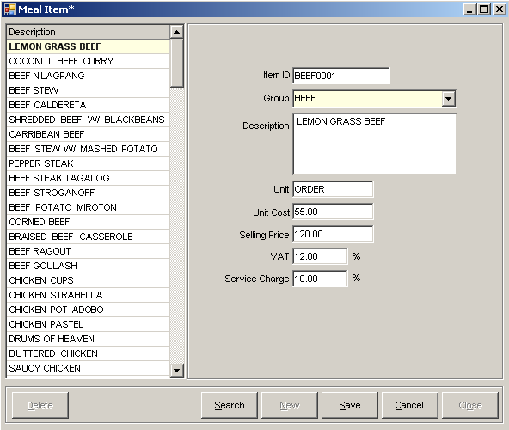
1
2
3
4
5
6
7
8
9
10
11
12
13
14
15

Figure 32

- List of Meal Items – enumerates all active Meal Items.
- Item Id text box – displays Item Id of selected Meal Item.
- Group Id drop-down box – displays Item group.
- Description text box – displays Meal Item description.
- Unit text box – displays Meal Item unit.
- Unit Cost text box – displays Meal Item unit cost.
- Selling price text box – displays Meal Item selling price.
- VAT text box – displays inclusive VAT of Meal Item.
- Service Charge – displays inclusive Service Charge of Meal Item.
- Delete button – removes selected Meal Item.
- Search button – search for a specific Meal Item.
- New button – prepares the screen for a new Meal Item entry.
- Save button – save changes to a new or existing Meal Item.
- Cancel button – discards any changes to Meal Item.
- Close button – close Meal Item screen.

⬧ How to Insert New Meal Item

  - Click NEW button. Input Item Id, and meal item description. Item Id is unique per Meal Item.
  - Once done, click the SAVE button.

⬧ How to Edit Information of a Meal Item

- Select Meal Item from List of Meal Items, and edit its information. Item Id is unique per Meal Item and can’t be altered.
- Once done, click the SAVE button.

⬧ How to DELETE Meal Item

- Select Meal Item from the List of Meal Items, and click the DELETE button.
- A confirmation box will appear, and click YES if you want to DELETE selected Meal Item.

23. Meal Groups – records all Meal Item’s group.
Location: ConfigurationEventsMealsMeal Group
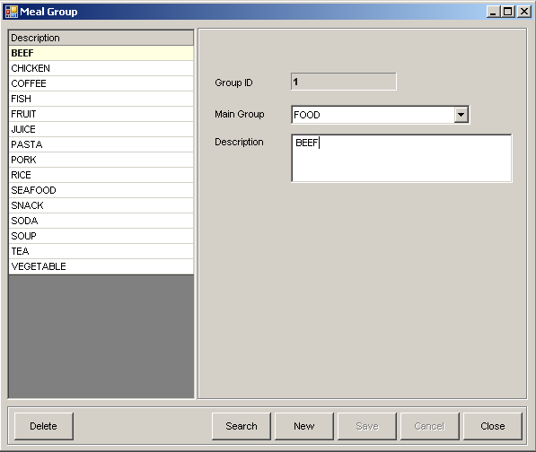
1
2
3
4
5
6
7
8
9
10

Figure 33

- List of Meal Groups – enumerates all active Meal Groups.
- Group Id – displays Meal Group Id.
- Main Group – displays Meal Group’s main group (Food or Beverage).
- Description – displays Meal Group description.
- Delete button – removes selected Meal Group.
- Search button – search for a specific Meal Group.
- New button – prepares the screen for a new Meal Group entry.
- Save button – save changes to a new or existing Meal Group.
- Cancel button – discards any changes to Meal Group.
- Close button – close Meal Group screen.

⬧ How to Insert New Meal Group

  - Click NEW button. Group Id is automatically set by the system. Select main group, and input meal group description. Group Id is unique per Meal Group.
  - Once done, click the SAVE button.

⬧ How to Edit Information of a Meal Group

- Select Meal Group from List of Meal Groups, and edit its information. Group Id is unique per Meal Group and can’t be altered.
- Once done, click the SAVE button.

⬧ How to DELETE Meal Item

- Select Meal Group from the List of Meal Groups, and click the DELETE button.
- A confirmation box will appear, and click YES if you want to DELETE selected Meal Group.

24. Meal Menu – records all Meal Menus. Meal Menus are collection of Meal Items for the purpose of having a combo meal.
Location: ConfigurationEventsMealsMeal Menus

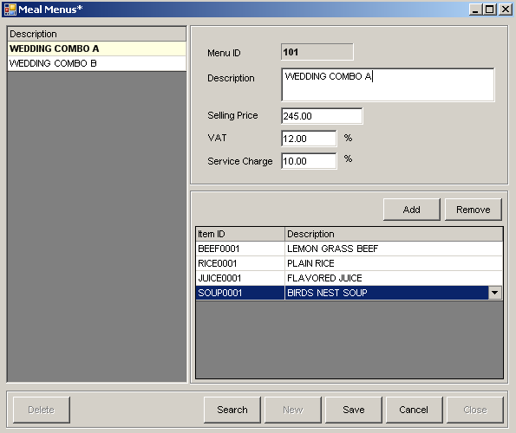
1
2
3
4
5
6
7
8
9
10
11
12
13
14
15

Figure 34

- List of Meal Menus – enumerates all active Meal Menus.
- Menu Id text box – displays Meal Menu Id.
- Description text box – displays description of Meal Menu.
- Selling Price text box – displays selling price of Meal Menu.
- VAT text box – displays inclusive VAT percentage of Meal Menu.
- Service Charge text box – displays inclusive Service Charge percentage of Meal Menu.
- Add button – add new meal item to the List of Meal Menu Items.
- Remove button – removes select meal item from the list of Meal Menu Items.
- List of Meal Menu Items – enumerate Meal Items included in the Meal Menu.
- Delete button – removes selected Meal Menu.
- Search button – search for a specific Meal Menu.
- New button – prepares the screen for a new Meal Menu entry.
- Save button – save changes to a new or existing Meal Menu.
- Cancel button – discards any changes to Meal Menu.
- Close button – close Meal Menu screen.

⬧ How to Insert New Meal Menu

  - Click NEW button. Menu Id is automatically set by the system. Input Meal Menu information. Menu Id is unique per Meal Menu.
  - Once done, click the SAVE button.

⬧ How to Edit Information of a Meal Menu

- Select Meal Menu from List of Meal Menus, and edit its information. Menu Id is unique per Meal Menu and can’t be altered.
- Once done, click the SAVE button.

⬧ How to Add Meal Item to Meal Menu

- Click Add button, and system adds an empty cell below the last meal item of the Meal Menu. Select a Meal Item from the list of meal items in the empty cell.
- Once done, click the SAVE button.

⬧ How to Remove Meal Item to Meal Menu

- Select an entry from the list of Meal Menu Items and click Remove button.
- Once done, click the SAVE button.

⬧ How to DELETE Meal Menu

- Select Meal Menu from the List of Meal Menus, and click the DELETE button.
- A confirmation box will appear, and click YES if you want to DELETE selected Meal Menu.

25. Individual Guests – records all information about a Guest.
Location: ConfigurationGuestsIndividual

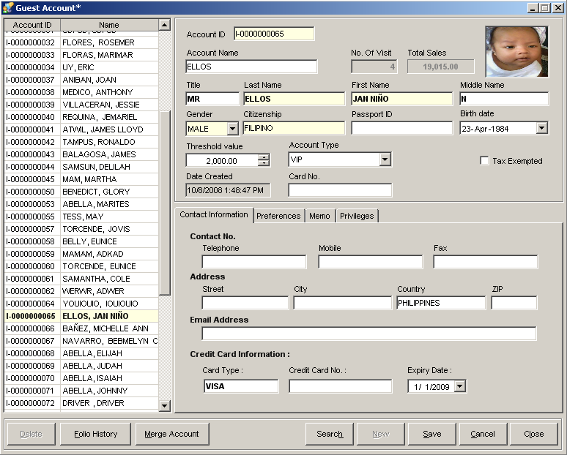
2
3
4
5
6
1
7
8
9
10
11
12
13
14
15
16
17
18
19
20
21
22
23
24
25
26
27
29
28
30
31

Figure 35

- List of Guests – enumerates all active Guest Accounts.
- Account ID text box – displays guest’s Account ID.
- Account Name text box – displays the Account Name or Display Name of the guest.
- No. of Visit text box – displays the guest’s total number of visits to the hotel.
- Total Sales text box – displays the Total Accumulated Sales of a guest based on his/her total visits.
- Guest Image – displays the guest’s image. To change this, just click on this box.
- Title text box – displays the Title of the guest.
- Last name text box – displays the last name of a guest.
- First name text box – displays the first name of a guest.
- Middle name text box – displays the middle name of a guest.
- Gender drop-down box – displays gender of a guest.
- Citizenship text box – displays the citizenship of a guest.
- Passport ID – displays the Passport ID of a guest. This field should not be left blank if guest is a non-resident of the country.
- Birth Date – displays the birth date of a guest.
- Threshold Value text box – displays the limit amount the guest can be charged.
- Account Type drop-down box – displays the type of account the guest has.
- Date Created – displays the date and time the account was created.
- Card No text box – displays the guest’s current privilege card number if guest has any.
- Tax Exempted check-box – displays if guest is exempted from tax or not.
- Contact Information tab – displays all contact information of a guest including contact numbers, address, email address and credit card information.
- Preferences tab – displays information of a guest regarding his preferences in rooms, foods, etc.
- Memo tab – displays other notes/information of a guest.
- Privileges tab – displays list of privileges a guest has.
- Delete button – removes selected guest account.
- Folio History button – displays history of guest’s visit to the hotel.
- Merge Account button – merges account to another account if both accounts are the same.
- Search button – search for a specific guest account.
- New button – prepares the screen for a new Guest Account.
- Save button – saves information to a new or existing Guest Account.
- Cancel button – discards any changes to Guest Account.
- Close button – close Guest Account screen.

⬧ How to Insert New Guest Account

  - Click NEW button. Account Id is automatically set by the system. Input Guest information. Account Id is unique per Guest Account.
  - Once done, click the SAVE button.

⬧ How to Edit Information of a Guest Account

- Select Guest Account from List of Accounts, and edit its information. Account Id is unique per Guest Account and can’t be altered.
- Once done, click the SAVE button.

⬧ How to DELETE Guest Account

- Select Guest Account from List of Accounts, and click the DELETE button.
- A confirmation box will appear, and click YES if you want to DELETE selected Guest Account.

⬧ How to Add Privileges

- Select Privilege tab and click on the Add button.
- A window containing list of privileges will appear. Select a privilege from the list and click on the Select button. Once done, click the Close button.
- Once privileges has been added, click the Save button to save all the changes made to the account.

⬧ How to Delete Privileges

- Select Privilege tab.
- Select from the list of privileges and click the Remove button.
- Once done, click the Save button.
Did you know that…..?

You can have a larger view of guest’s image. Just point your mouse over the guest image box and a bigger image will appear.
If you entered details of guest’s Credit Card, this will be automatically shown in the Credit Card information of a guest’s Folio once the guest pays via Credit Card.

26. Group Guests – records all Company Accounts.
Location: ConfigurationGuestsGroup
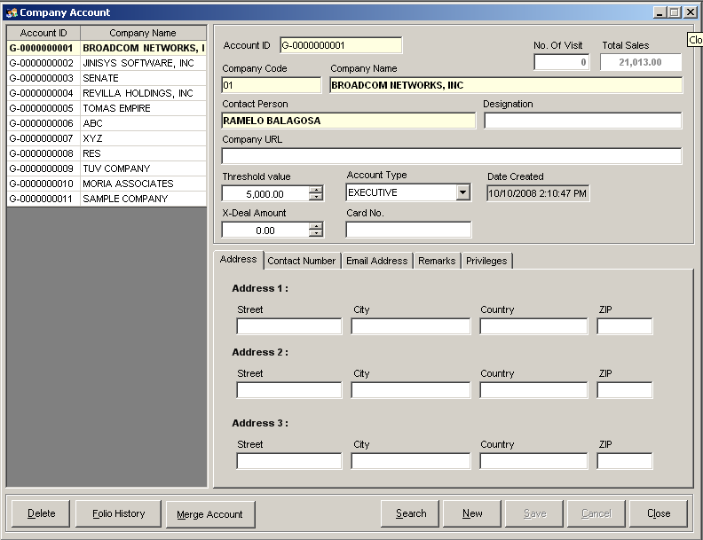
2
5
3
4
6
7
8
9
1
10
11
12
13
14
15
21
20
19
18
17
16
27
26
25
24
23
22

Figure 36

- List of Accounts – enumerates all active Company Accounts.
- Account ID text box – displays Company’s Account ID.
- No. of Visit text box – displays the Company’s total number of visits to the hotel.
- Total Sales text box – displays the total accumulated sales for the company.
- Company Code text box – displays the company code or the display name for the account.
- Company Name text box – displays the Name of the Company.
- Contact Person text box – displays the name of the contact person in the company.
- Designation text box – displays the designation or position of the contact person in the company.
- Company URL text box – displays the Company’s website URL.
- Threshold Value text box – displays the limit amount the Company can be charged.
- Account Type drop-down box – displays the type of account the Company currently has.
- Date Created – displays the date and time the account was created.
- X-Deal amount text box – displays the X-Deal amount the Company and the Hotel has agreed upon.
- Card No text box – displays the current privilege card number of the Company.
- Address tab – contains all addresses of the Company.
- Contact Number tab – contains all contact numbers of the Company.
- Email Address tab – contains all email addresses of the Company.
- Remarks tab – contains other information/remarks regarding the Company.
- Privileges tab – contains all privileges of the Company.
- Delete button – removes selected Company Account.
- Folio History button – displays history of Company’s visit to the Hotel.
- Merge Account button – merges account to another account if both accounts are the same.
- Search button – search for a specific Company Account.
- New button – prepares the screen for a new Company Account.
- Save button – saves information to a new or existing Company Account.
- Cancel button – discards any changes to Company Account.
- Close button – close Company Account screen.

⬧ How to Insert New Company Account

  - Click NEW button. Account Id is automatically set by the system. Input all information regarding the Company. Account Id is unique per Company Account.
  - Once done, click the SAVE button.

⬧ How to Edit Information of a Company Account

- Select Company Account from List of Accounts, and edit its information. Account Id is unique per Company Account and can’t be altered.
- Once done, click the SAVE button.

⬧ How to DELETE Company Account

- Select Company Account from List of Accounts, and click the DELETE button.
- A confirmation box will appear, and click YES if you want to DELETE selected Company Account.

⬧ How to Add Privileges

- Select Privilege tab and click on the Add button.
- A window containing list of privileges will appear. Select a privilege from the list and click on the Select button. Once done, click the Close button.
- Once privileges has been added, click the Save button to save all the changes made to the account.

⬧ How to Delete Privileges

- Select Privilege tab.
- Select from the list of privileges and click the Remove button.
- Once done, click the Save button.

26. Taxi Drivers – records all information of a Taxi Driver.
Location: ConfigurationDrivers
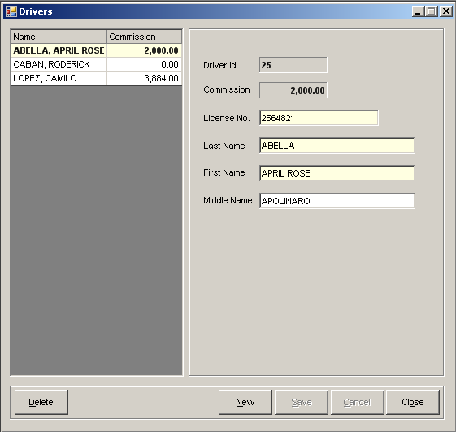
1
2
3
4
5
6
7
8
9
10
11
12

Figure 37

- List of Accounts – enumerates all active Taxi Driver’s Accounts.
- Driver ID text box – displays Driver’s ID.
- Commission text box – displays the total accumulated Commission Amount of the Taxi Driver.
- License No. text box – displays the Taxi Driver’s license number.
- Last name text box – displays the last name of the taxi driver.
- First name text box – displays the first name of the taxi driver.
- Middle name text box – displays the middle name of the taxi driver.
- Delete button – removes the selected Driver Account.
- New button – prepares the screen for a new Driver Account.
- Save button – saves information to a new or existing Driver Account.
- Cancel button – discards any changes to Driver’s Account.
- Close button – close Driver Account screen.

⬧ How to Insert New Taxi Driver

  - Click NEW button. Driver Id is automatically set by the system. Input all information regarding the driver. Driver Id is unique per Driver Account.
  - Once done, click the SAVE button.

⬧ How to Edit Information of a Company Account

- Select Company Account from List of Accounts, and edit its information. Account Id is unique per Company Account and can’t be altered.
- Once done, click the SAVE button.

⬧ How to DELETE Company Account

- Select Company Account from List of Accounts, and click the DELETE button.
- A confirmation box will appear, and click YES if you want to DELETE selected Company Account.

27. System Users – records all information regarding the users of the system.
Location: ConfigurationHotelSystem Users

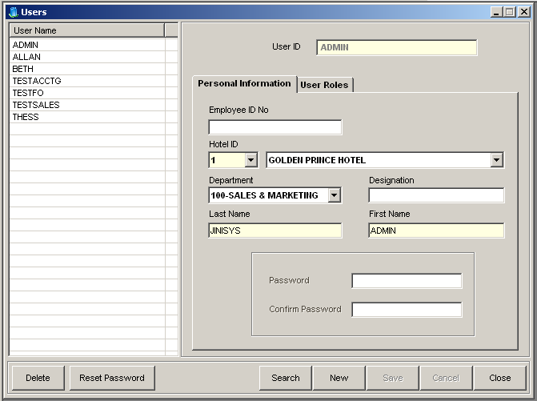
2
1
4
3
5
7
6
8
9
10
11
12
13
14
15
16
17
18

Figure 38

- List of Accounts – enumerates all active User Accounts.
- User ID text box – displays the User’s ID.
- User Roles tab – contains a list of Roles the User have.
- Employee ID No text box – displays the user’s Employee ID.
- Hotel ID drop-down box – displays the Hotel ID the user is assigned to.
- Hotel Name text box – displays the name of the Hotel.
- Department drop-down box – displays the Department the user is assigned to.
- Designation text box – displays the designation or position of the user in the assigned department.
- Last name text box – displays the last name of the user.
- First name text box – displays the first name of the user.
- Password box – allows changing of passwords with confirmation.
- Delete button – removes selected user account.
- Reset Password button – clears current user password and ask for new password.
- Search button – search for a specific user account.
- New button – prepares the screen for a new User Account.
- Save button – saves information to a new or existing user account.
- Cancel button – discards any changes made to the User Account.
- Close button – closes the User Account window.

⬧ How to Insert New User Account

  - Click NEW button. Input all information regarding the User especially its User ID. User Id is unique per User Account.
  - Once done, click the SAVE button.

⬧ How to Edit Information of a User Account

- Select User’s Account from List of Accounts, and edits its information. User Id is unique per User Account and can’t be altered.
- Once done, click the SAVE button.

⬧ How to DELETE User Account

- Select User Account from List of Accounts, and click the DELETE button.
- A confirmation box will appear, and click YES if you want to DELETE selected User Account.

⬧ How to Add Roles

- Select User Roles tab and click on the Add Role button.
- Click on the Role column then select a role. Once done, click the Close button.
- Once roles has been added, click the Save button to save all the changes made to the account.

⬧ How to Delete Privileges

- Select User Roles tab.
- Select from the list of roles and click the Remove Role button.
- Once done, click the Save button.

⬧ How to Reset Password

- Click on the Reset Password button.
- Enter new password and confirm the password you entered.
- Once done, click the Save button.

28. User Roles – records the roles of users.
Location: ConfigurationHotelSystem Roles

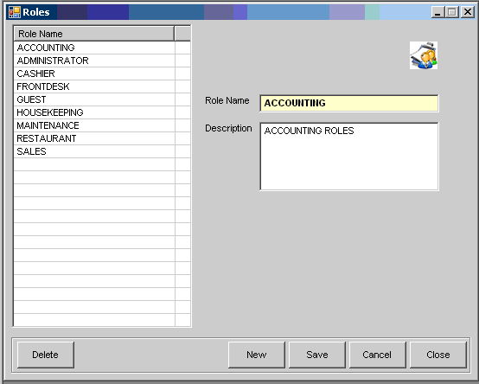
2
3
1
4
5
6
7
8

Figure 39

- List of Roles – enumerates all active User Roles.
- Role Name text box – displays the name of the role.
- Description text box – displays the description of the role.
- Delete button – removes the selected user role.
- New button – prepares the screen for a new User Role.
- Save button – saves changes to a new or existing User Role.
- Cancel button – discards any changes to the User Role.
- Close button – closes the window for User Roles.

⬧ How to Insert New User Role

  - Click NEW button. Input all information regarding the User role. Role Name is unique per User Role.
  - Once done, click the SAVE button.

⬧ How to Edit Information of a User Role

- Select a Role from List of Roles, and edit its information. Role Name is unique per User Role and can’t be altered.
- Once done, click the SAVE button.

⬧ How to DELETE User Role

- Select a Role from the List of Roles, and click the DELETE button.
- A confirmation box will appear, and click YES if you want to DELETE selected User Role.

29. System Configuration – records all configurations of the system, e.g. default breakfast value, default cash terminal.
Location: ConfigurationHotelSystem Configuration
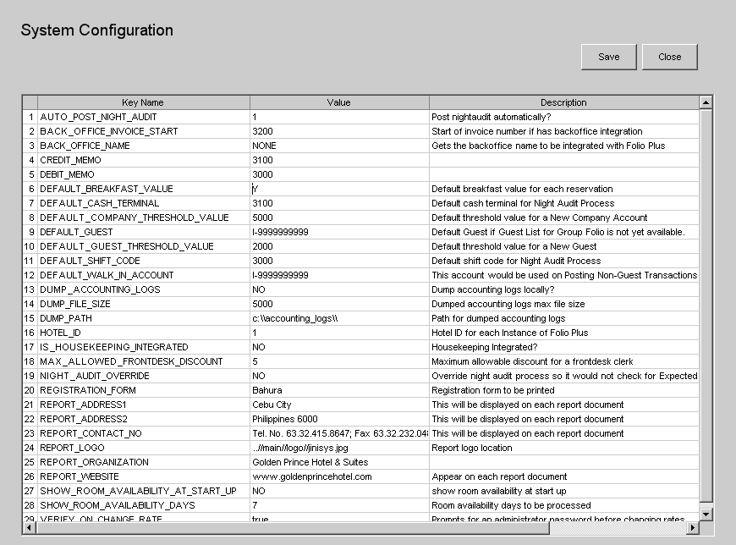
1
2
3

Figure 40

- List of Configurations – enumerates all system configurations with their values.
- Save button – saves all changes to configurations.
- Close button – closes the window for system configuration.

⬧ How to Edit Information of a System Configuration

  - Select a Configuration from List of Configurations, and edit its information.
  - Once done, click the SAVE button.

III. TRANSACTIONS (BASIC)

1. Guest List – displays all guests that are checked-in or reserved at the hotel.
Location: Transactions  Frontdesk  Guest List
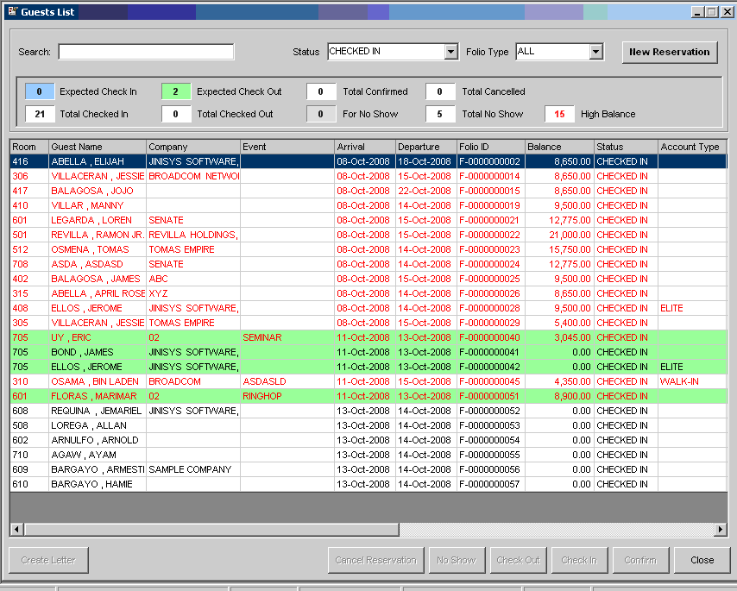
1
2
3
4
5
6
7
8
9
10
11
12
13

Figure 41

- List of Guests – enumerates all guests of the hotel filtered by their status. Default is Checked In.
- Search text box – field for entering search criteria for searching a specific guest.
- Status drop-down box – status criteria for displaying guests in the grid.
- Folio Type drop-down box – folio type criteria for displaying guests in the grid.
- New Reservation button – creates a new Individual Reservation.
- Guest Count box – displays the total count of guests for each category.
- Create Letter button – creates a letter for selected High Balanced guest.
- Cancel Reservation button – cancels a selected reservation.
- No Show button – cancels a selected reservation and set its cancel reason to No Show.
- Check Out button – checks out a selected checked in guest.
- Check In button – checks in a selected reserved guest.
- Confirm button – confirms a reservation of a guest.
- Close button – closes the window for Guest List.

⬧ How to Search for a Guest

  - Select from status drop-down box the status of the guest then input any searching characters in the search field.
  - Once done, click the ENTER key. System will automatically search the grid and highlights the row that matches the criteria.

⬧ How to Create New Reservation

- Click on the New Reservation button. The Individual Reservation screen shows.
- Input the details of the reservation and once done, click on the Save button.
- Once the window of the Individual Reservation closes, the newly added reservation will be shown in the grid under Confirmed status.

⬧ How to Cancel Reservation

- Select the reservation to be cancelled from the list of guests in the grid.
- Click the Cancel Reservation button. A window will prompt you for a reason. Enter the reason for cancellation.
- Once done, click on the OK button. The reservation will now be removed in the Guest List.
Did you know that…..?

You can easily identify the status of an account by the highlight color of a row or its font color. There are color legends in the Guest Count box to help you determine the status of an account, e.g.: light blue – expected check-in, light green – expected check-out.
You can also select and right-click a row to view other options for a specific folio.
You can also view the Guest List by pressing F4 or create New Reservation by pressing F6

2. Single Reservation – creates new Individual Reservation
Location: Transactions  Frontdesk  Single Reservation
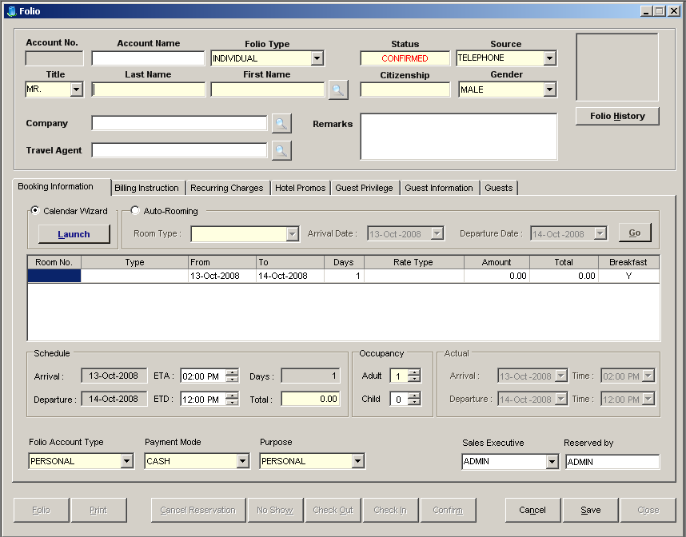
1
2
3
4
5
6
7
8
9
10
11
12
13
16
14
15
17
18
19
20
21
22

Figure 42

- Folio Information box – contains information regarding the Reservation: last name and first name of Guest, Folio Type, Remarks, and Company…
- Calendar Wizard box – launches the Room Calendar for easy room reservation.
- Schedule grid – displays information of room schedules: room number, type, date from and to, rate type…
- Schedule box – displays information regarding the expected schedule of the folio: expected arrival date and departure, expected time of arrival and departure…
- Occupancy box – displays information regarding the number of pax (adult/child) included in the folio.
- Actual Schedule box – displays information regarding the actual schedule of the folio.
- Auto-Rooming box – automatically select an available room based on the room type and schedules indicated.
- Folio Account Type drop-down box – displays information of the account type the folio is using.
- Payment Mode drop-down box – displays information as to what payment type the folio will be using.
- Purpose drop-down box – displays the purpose of the guest for staying in the hotel.
- Sales Executive drop-down box – displays the Sales Executive who transacted the account.
- Reserved by text box – displays the user that reserved the folio.
- Folio button – shows the Folio Ledger of the account.
- Print button – prints the Folio of the guest.
- Cancel Reservation button – lets you cancel the reservation.
- No Show button – cancels the reservation and set its cancellation reason to No Show.
- Check Out button – sets the status of the folio to Check Out.
- Check In button – sets the reservation status of the folio to Check In.
- Confirm button – confirm the reservation status of the folio.
- Cancel button – discards any changes made to the account.
- Save button – saves changes to a new or existing reservation.
- Close button – closes the Individual Reservation window.

⬧ How to Add Room Schedule to Reservation using Manual Input

  - In the schedule grid under the Room No column, enter the room number of the room the guest wished to reserve.
  - After inputting, its room type will automatically show in the next column. Input other details of the room’s schedule in its appropriate column.

⬧ How to Add Room Schedule to Reservation using Calendar Wizard
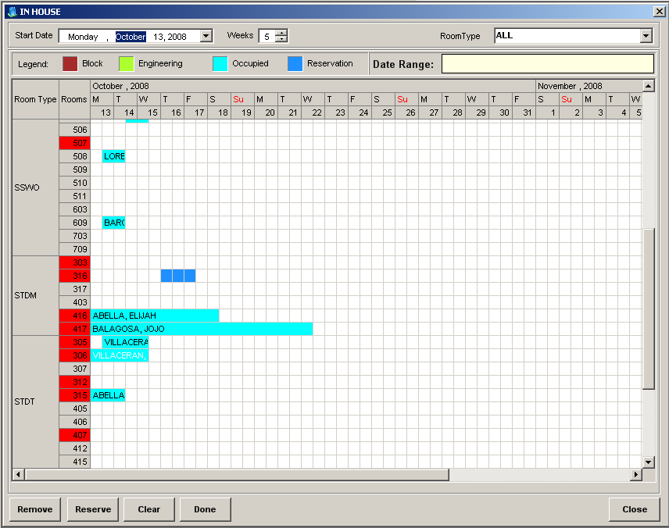

Editing Area
Types of Room
and room numbers

Figure 43
- Select Calendar Wizard then click on the Launch button. The Room Calendar will show.
- Select Room Type and Room Number of the room the guest wished to occupy by highlighting the cells of the selected room row and date range column in the editing area.
- Once done, click on the Reserve button then close the window. Room number and date range will automatically be set in the schedule grid.

⬧ How to Add Room Schedule to Reservation using Auto-Rooming

- Select Auto-rooming radio button. The group box for auto-rooming will be enabled.
- Select room type from the drop down box and the date range of the room schedule.
- Once done, click on the Go button. System will automatically set room number and date range on the schedule grid.

Did you know that…..?

You can add multiple room schedules in one folio? Or automatically transfer guest room in another room on a specified date? To do this, you just right click on the schedule grid and select the Add Schedule option. This will allow you to input room schedule details again.

⬧ How to Add/Remove Room Billing Instructions to Folio
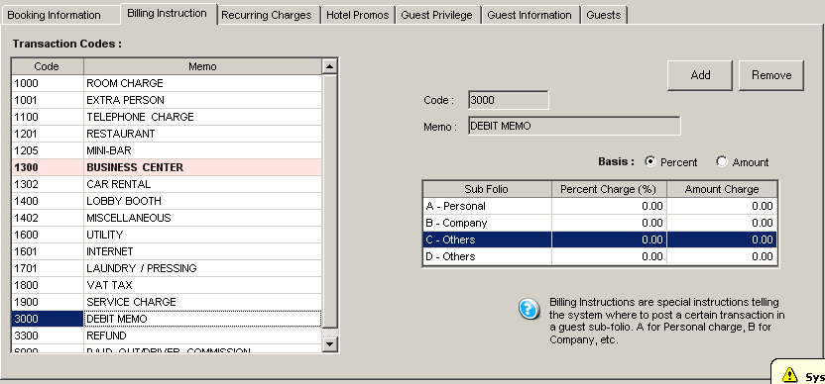

Figure 44

- Select the Billing Instructions tab. It will display all the transaction codes.
- To add billing instructions, select a transaction from the list of transactions. On the right side of the screen shows the sub-folios with their corresponding charges.
- Select the basis of transferring the amount – Percentage or Amount.
- Input the value to be transferred for each of the sub-folio. If percentage is selected, total percentage of all sub-folios should be 100%.
- Once done, click on the Add button. A transaction with pink highlight indicates that there is an instruction for that specific transaction.
- To remove billing instructions, just select a transaction then click on the Remove button.
Did you know that…..?

Billing Instructions are special instructions telling the system where to post a certain transaction and as to how much it will post in a guest sub-folio.

⬧ How to Add/Remove Recurring Charges
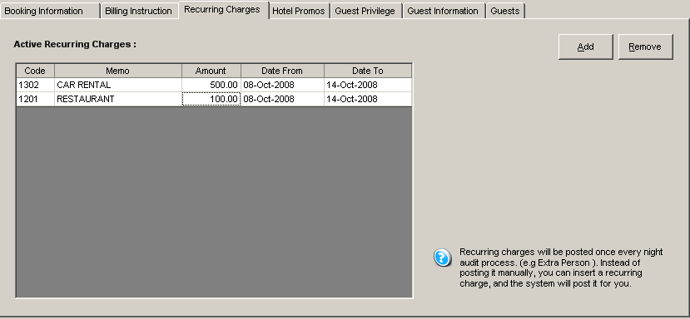

Figure 45
- Select the Recurring Charges tab. It will display all active recurring charges of a guest folio, if it has any.
- To add a recurring charge, just click on the Add button. A window with a list of Transaction Codes will display. Select a transaction from the transaction list.
- Once done, click on the Close button. All selected transactions are shown in the recurring charges grid. Enter details for the recurring charges such as amount to be posted and date range.
- To remove a recurring charge, just select the transaction to be removed from the grid then click on the Remove button.
Did you know that…..?

Recurring charges are those charges that are included in the guest’s folio and occur at a specified date range. If for example you manually insert a transaction everyday for extra person, recurring charges can do this for you. Just insert a charge here with a specified date range, and the system will do the posting for you.

⬧ How to Add/Remove Hotel Promos

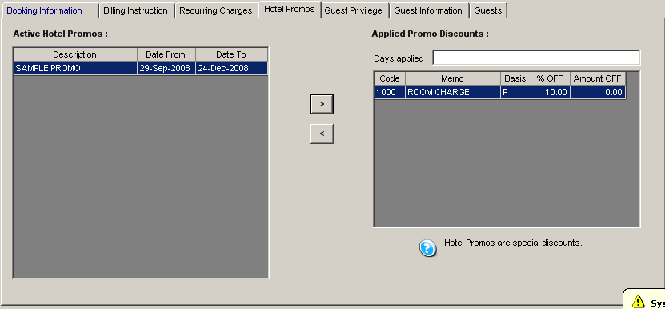

Figure 46

- Select the Hotel Promos tab. It will display all active hotel promos and if already applied, will show its discount details on the grid at the right side.
- To add a promo to the guest folio, just select a promo from the list of active hotel promos then click on the less than symbol to add its discount details.
- To remove a promo, just select the discount details then click on the greater than symbol.

Did you know that…..?

Hotel Promos are special discounts of the hotel given to guests in a specified date range.
Only one promo is applicable to a folio. If for example a guest has privileges and they have the same transaction discounts with the hotel promo, the higher discount rate will prevail.

⬧ How to Add/Remove Guest Privilege

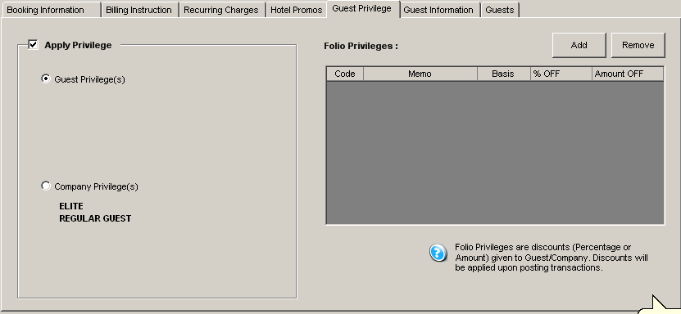

Figure 47

- Select the Guest Privilege tab. It will display list of folio privileges, if folio has any.
- If guest has a privilege in its individual account, check the Apply Privilege check box and select Guest Privilege radio button. System will automatically display the guest’s privileges in the list of privileges.
- If guest is under a company and wants to avail the company’s privileges, just select the Company Privilege radio button and system will automatically display the company’s privileges.
- To manually add a privilege, just click on the Add button. A window with a list of transactions will display. Select the transactions that will be discounted.
- Once done, close the window. Folio Privileges list will now display all those selected transactions. Enter details of the privilege such as basis of discount – P for percentage and A for amount, and the value or amount. If percentage is selected, it should not be greater than 100.
- To remove a privilege, just select the privilege to be removed from the list then click on the Remove button.
Did you know that…..?

Folio Privileges are discounts (Percentage or Amount) given to a guest/company. This will be applied upon posting of transactions.

⬧ How to Add/Remove Guests

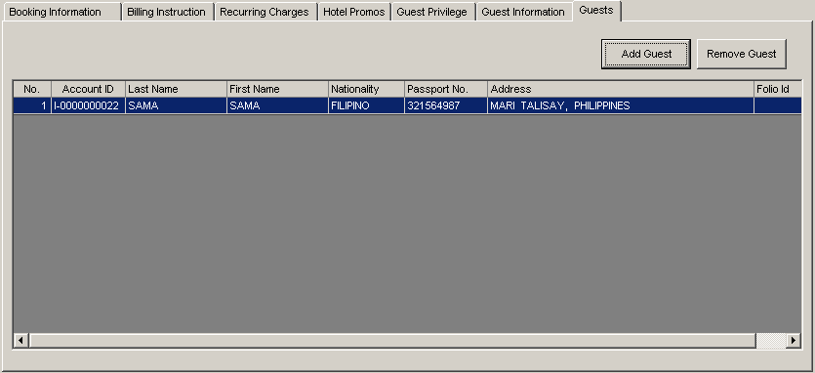

Figure 48

- Select the Guests tab. It will display a list of guests that are included in the folio.
- To add guest to the folio, click on the Add Guest button. The Individual Account Screen will display.
- Select from the list the guest you want to add. Once done, click on the close button.
- Guests that have been selected are now listed in the list of guests. Number of adult pax will change to the total number of guests including the master guest account.
- To remove a guest, simply select from the list then click on the Remove Guest button.

3. Check-In through Reservation

⬧ Check-In using the Guest List

- View the Guest List screen then select the reservation to be checked-in.
- Click on the Check-In button. System will prompt a message if date is earlier than the scheduled reservation date.
- Once done, status of the folio will now be Checked-In.

⬧ Check-In by viewing the Folio

- View the Folio Information by selecting from the Guest List screen the reservation to be checked-in.
- Click on the Check-In button. System will prompt a message if date is earlier than the scheduled reservation date.
- Once done, status of the folio will now be Checked-In.

⬧ Check-In using the Room Status

- In the Room Status window, rooms that are reserved are highlighted in blue.
- Select the reserved room then right click on it. Select Check-In from the options enumerated.
- Once done, status of the folio will now be Checked-In.

4. Check-In through Walk-In

⬧ Check-In using the Room Status

- Select an available room in the Room Status window.
- Double click or right click then Quick Check-In the selected room. The Individual Reservation screen displays.
- Input details of the guest’s stay.
- Once done, click on the Save button. System will automatically save the reservation and set its status to Checked-In.

5. Folio Ledger List – displays summary of charges of all Checked-In Individual/Group.
Location: Transactions → Cashiering → Folio Ledgers (F11)

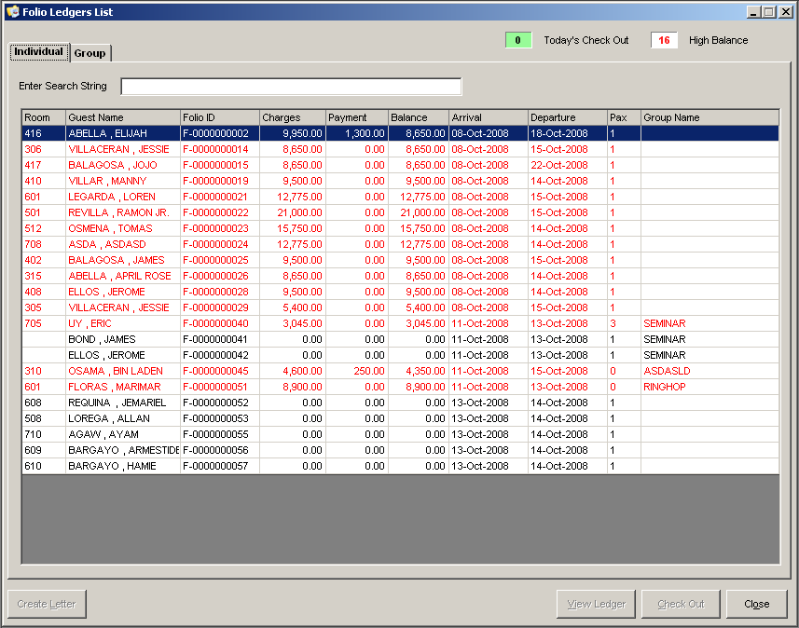
1
2
3
4
5
6
7
8

Figure 49

- Individual tab – displays a list of Individual Guest Accounts that are checked-in.
- Group tab – displays a list of Group Accounts that are checked-in.
- Check-Out box – displays the total number of guests that are expected to check-out.
- High Balance box – displays the total number of guests that have reached the maximum threshold.
- Create Letter button – creates a letter for high balanced guests.
- View Ledger button – displays the individual Folio Ledger of a selected Guest Account.
- Check Out button – displays the window for checking out a guest.
- Close button – closes the Folio Ledger List window.

6. Folio Ledger – displays all transactions of a specified folio.
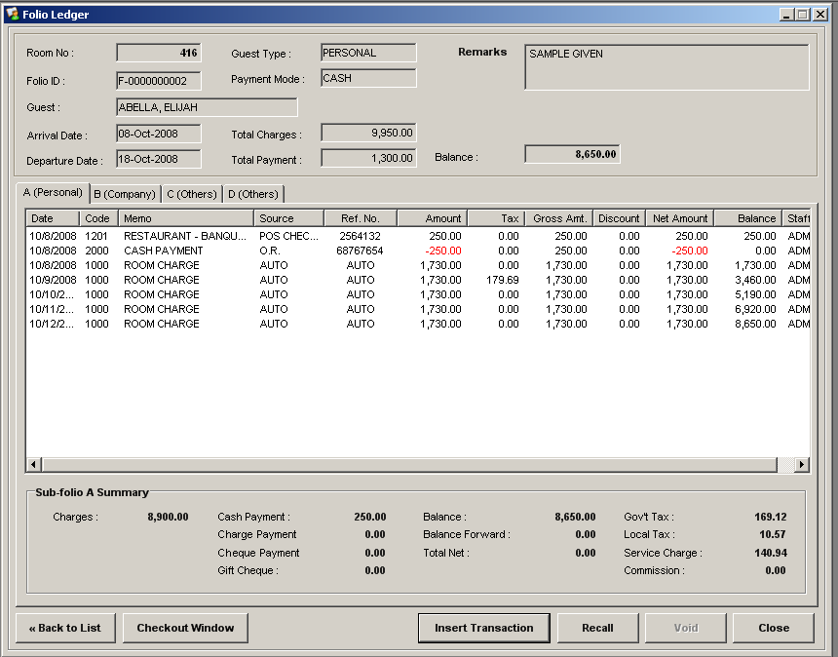

1

2

3
4
5
6
7
8

9

Figure 50

- Folio Information box – displays the details of the folio including the total charges, payments and balances of all sub-folios.
- Sub-Folios tab – displays all transactions (charges, payments) of a particular sub-folio.
- Sub-Folio Summary tab – displays the total charges, payments and other transaction break-downs of a selected sub-folio.
- Back to List button – closes the Folio Ledger window and goes back to the Folio Ledgers List window.
- Checkout Window button – closes the Folio Ledger window and displays the window for Check-Outs.
- Insert Transaction button – opens the window for inserting transactions like payments and charges.
- Recall button – opens the window for voided transactions.
- Void button – voids a selected transaction.
- Close button – closes the Folio Ledger button.

⬧ How to Insert Transaction (Charges / Payments)
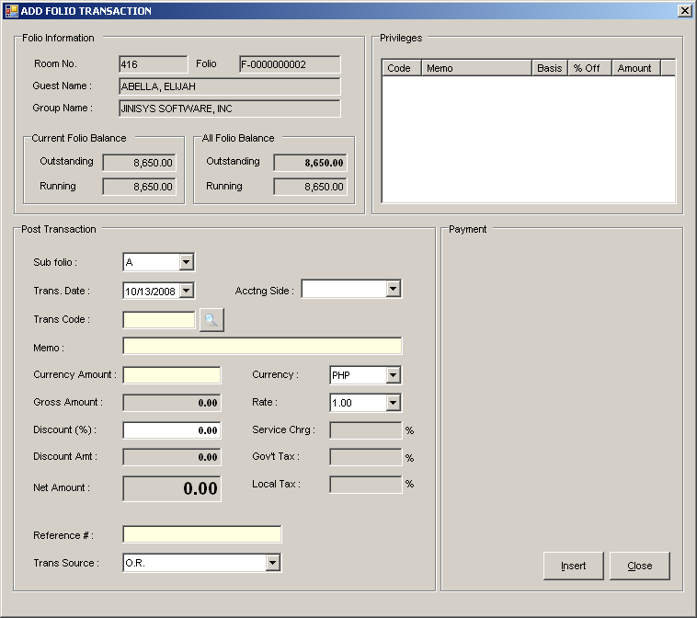
Folio Information including total balances of all folios and balances of selected folio
Displays list of Folio Privileges

Figure 51

      - Click on the Insert Transaction button. The Add Transaction window will appear.
      - Enter transaction code in the appropriate field or click on the browse transaction button.
      - Input transaction details.
      - If transaction is a charge transaction and guest pays at once, input payment details in the payment area.
      - Once done, click on the Insert button. Transaction will now be displayed on the specified sub-folio’s list of transactions.

⬧ How to Recall Voided Transactions
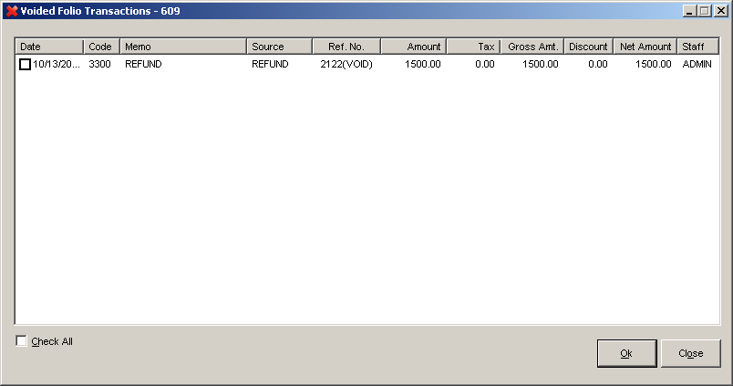

Figure 52

- Click on the Recall button. The Voided Folio Transactions window will be shown.
- Check the boxes of the transactions you want to recall.
- Once done, click the OK button. Transactions selected will now be shown in the list of transactions.

⬧ How to Void Transactions

- Select the transaction you want to void then click on the Void button.
- A confirmation message will prompt if user wants to void transaction. If user will proceed, click on the Yes button.
- Transaction will be removed from the list and its status will be changed to void.

7. Check Out Folio – checks out a specified folio.

⬧ How to view the Check Out Window

- In the Room Status window, right click on the room to be checked out and select Check Out.
  - In the Folio Information window, click on the Check Out button.
  - In the Guest List, click on the Check Out button.

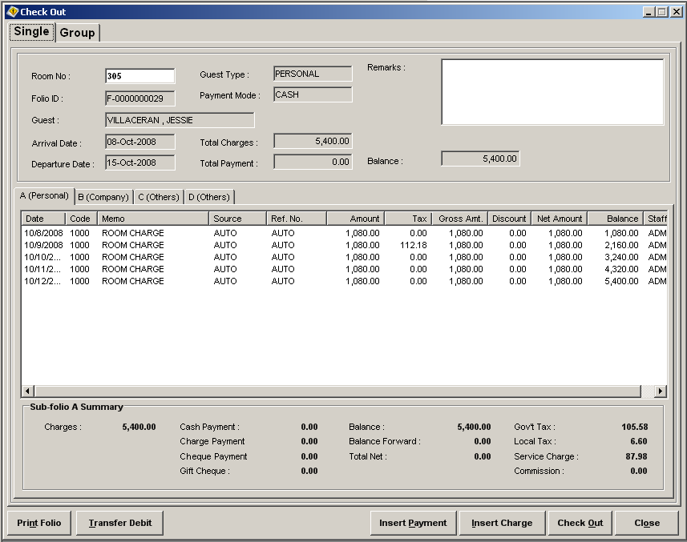
1
2
3
4
5
6
7
8
9

Figure 53

- Folio Information box – displays the details of the folio including the total charges, payments and balances of all sub-folios.
- Sub-Folio Transaction Details box – displays all transactions (charges/payments) of a selected sub-folio.
- Sub-Folio Summary box – displays total computations (payments, charges and other breakdowns) for a selected sub-folio.
- Print Folio button – print a report for all transactions of the folio.
- Transfer Debit button – opens the Transfer Debit window that allows transferring of a transaction folio to another folio.
- Insert Payment button – opens the Transaction window for payments and allows you to add payment transactions.
- Insert Charge button – opens the Transaction window for charges and allows you to add charged transactions.
- Check Out button – update the status of the folio to Check Out.
- Close button – closes the Checkout window.

⬧ How to Transfer Debit
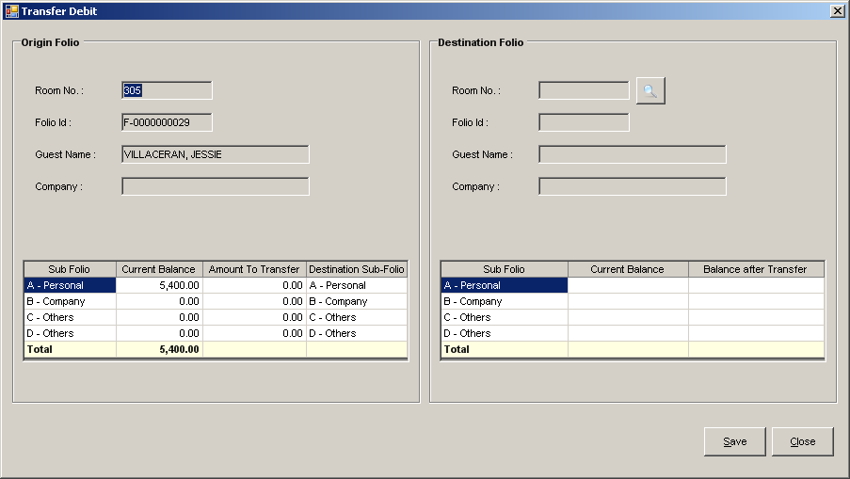

Figure 54

- Click on the Transfer Debit button. The Transfer Debit window will be shown.
- The folio information will be displayed on the Origin Folio box. Select room number or folio from the Destination Folio box which will serve as the account where you want to transfer the amount.
- In the Origin Folio grid, input the amount you want to transfer from any sub-folio then select the destination sub-folio you want the amount to transfer.
- Once done, click on the Save button.
- In the Check Out window, entry for folio transfer will be displayed including the amount that you have just transferred.

⬧ How to Check Out Folio

- Click on the Check Out button.
- If folio’s remaining balance is not zero, settle account first by inserting payments.
- If folio’s remaining balance is zero, a message will prompt you that check out is successful. Guest’s folio will be printed afterwards.
- Room status of the previously checked out folio will be updated to vacant dirty.

8. Opening / Closing Shift – allows user to open / close shift for cashiering.
Location: Transactions → Cashiering → Open Shift / Cash Drawer
Location: Transactions → Cashiering → Close Shift / Cash Drawer

⬧ How to Open Cash Drawer

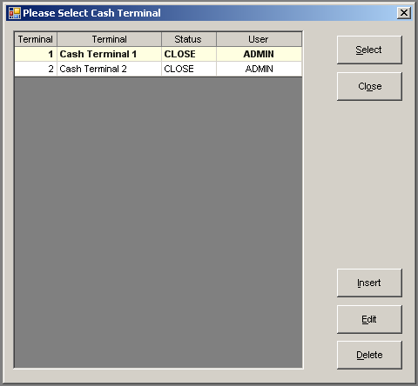

Figure 55

- Open the Open Shift / Cash Drawer window.
- Select the Terminal of the Cash Drawer you want to open then click on the Select button. The Open Shift window will appear.

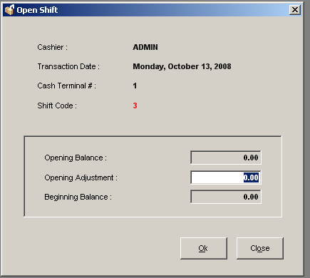

Figure 56

- Input opening adjustment amount.
- Once done, click on the OK button. Cashier is now open for any transactions.

⬧ How to Close Cash Drawer

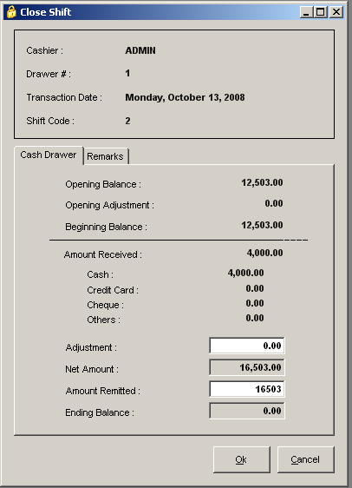

Figure 56

- Open the Close Shift / Cash Drawer window.
- Input amount details to be remitted and any remarks for the closing of shift.
- Once done, click on the OK button. Shift will now be closed and reports for the closed cashier shift will be printed.

9. Day-End Closing – allows user to execute the night audit operation.
Location: Transactions → Night Audit → Day-End Closing

⬧ How to Process Night Audit
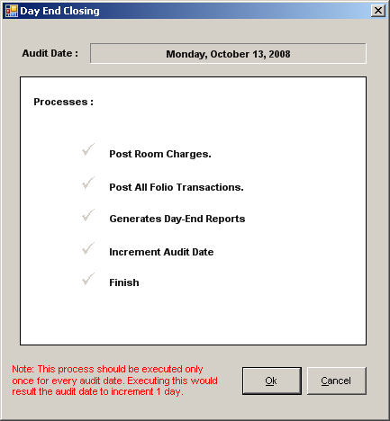

Figure 57

- Open the Day-End Closing window.
- Expected guest arrivals and departures should be zero before proceeding with the night audit. If greater than zero, user should cancel first all expected arrivals and settle all expected departures.
- Once ready, click on the OK button.
- System will automatically post room charges and other transactions, and increment the date to 1 day. Reports will also be generated after the operation.

Did you know that…..?

Night Audit automatically processes all room charges and other auto-posting transactions. It also increments the system date to 1 day therefore this process should only be executed once.

